Uploads of juhi

# Question: What is automation documentation?

No file uploaded because only text was provided.

# Question: Why is it important in software processes?

**Row 1, Col 3: camera_capture.png**



**Row 2, Col 3: 23170JuhiLabAOTSubmitted.pdf**

Page 1

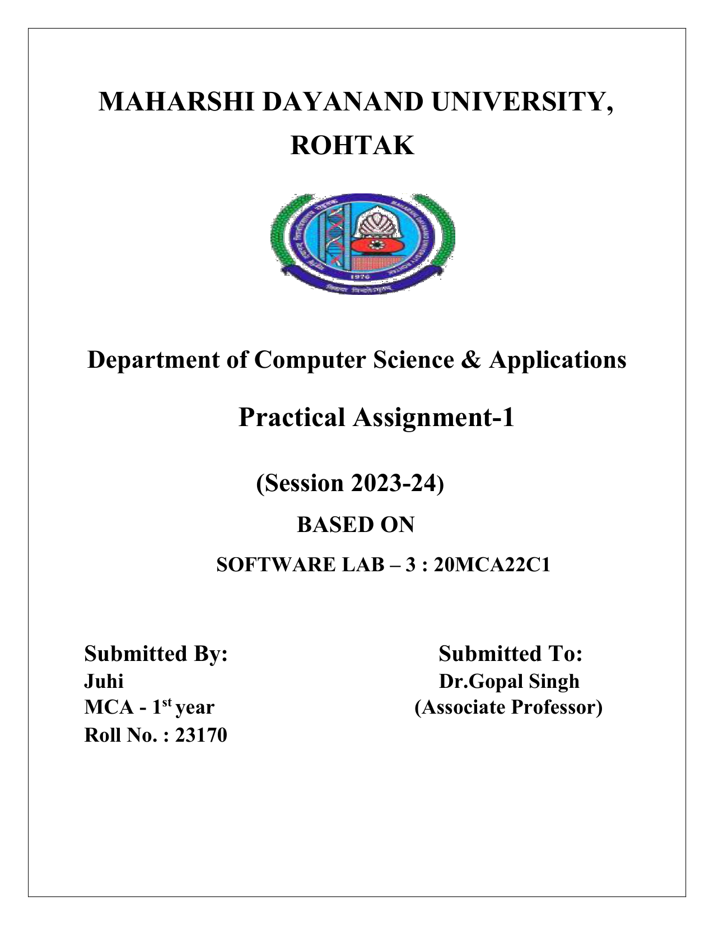

Page 2

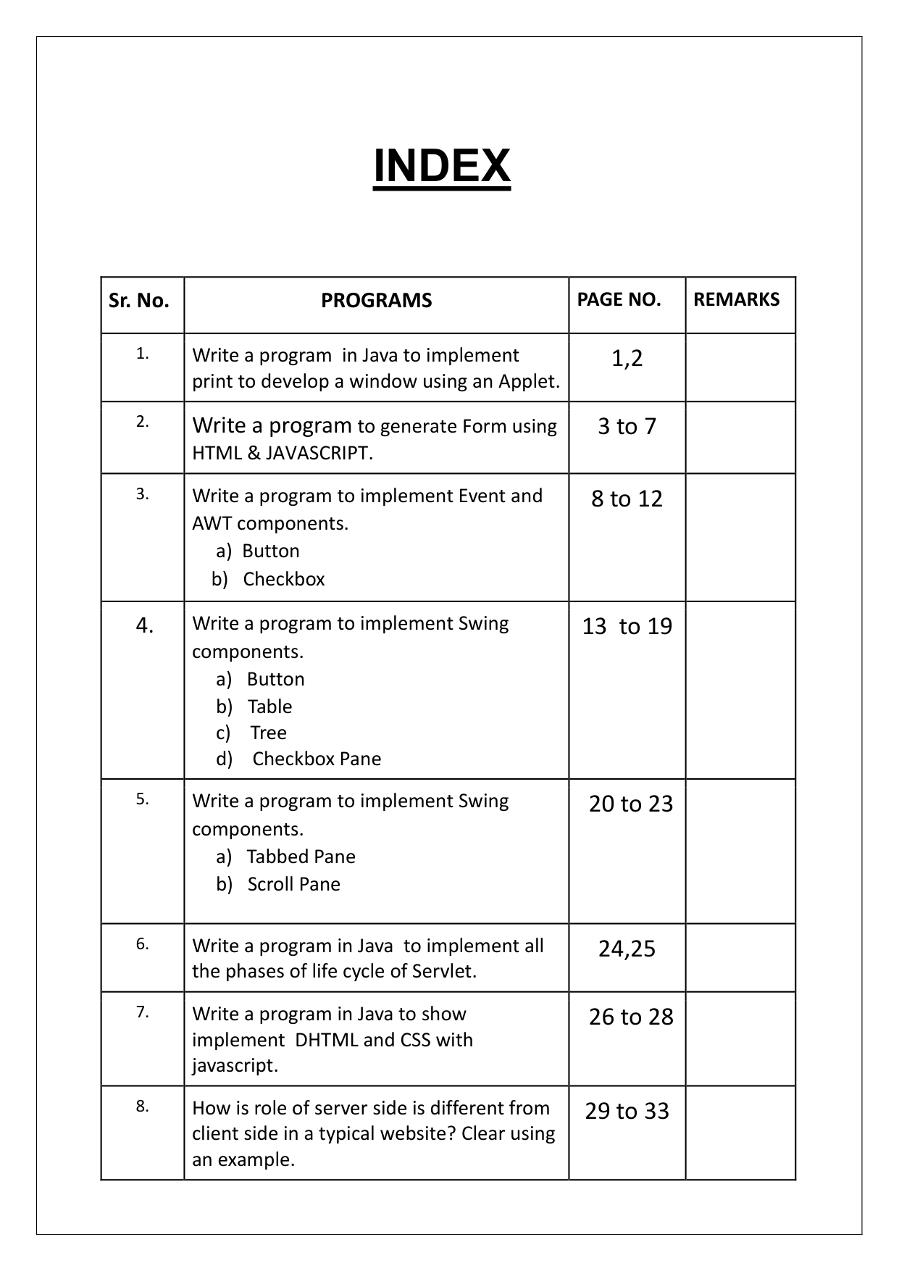

Page 3

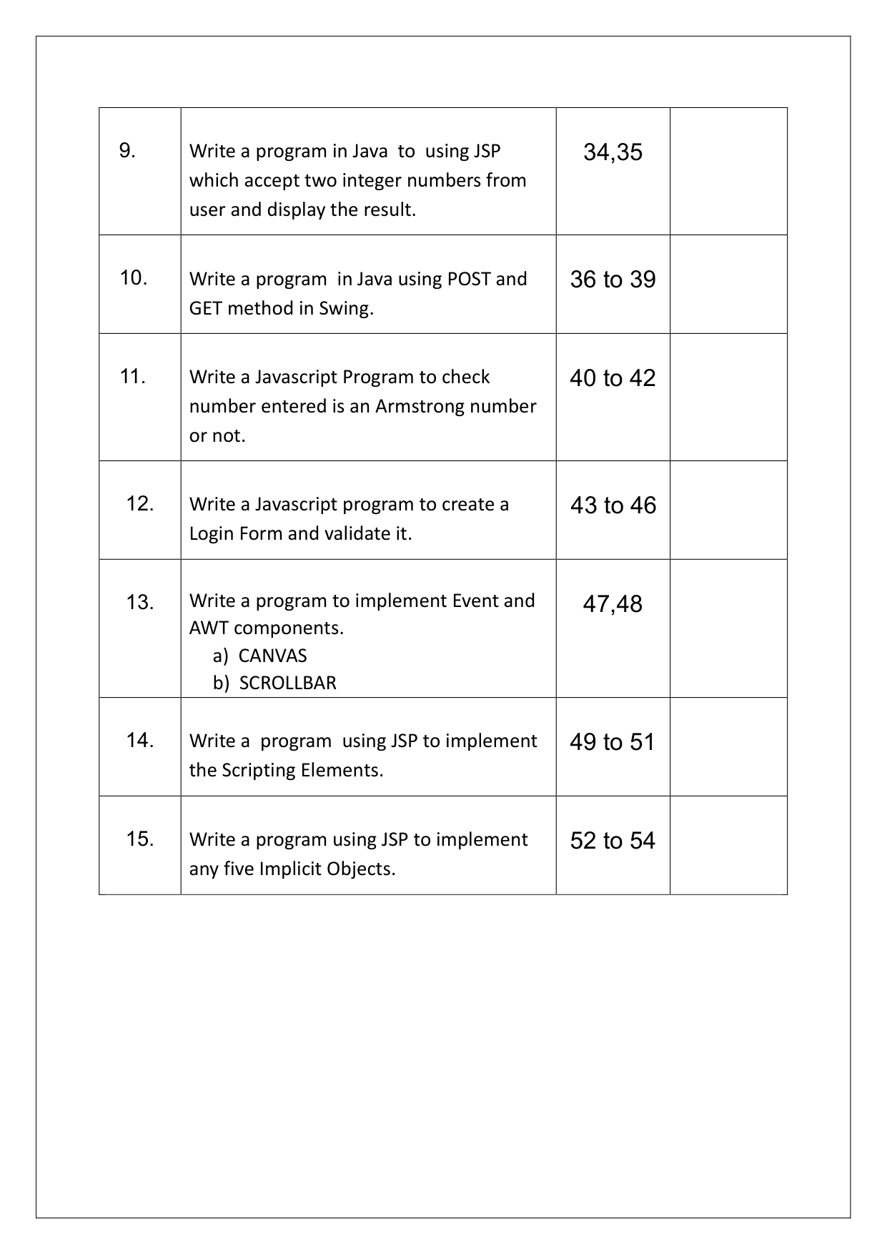

Page 4

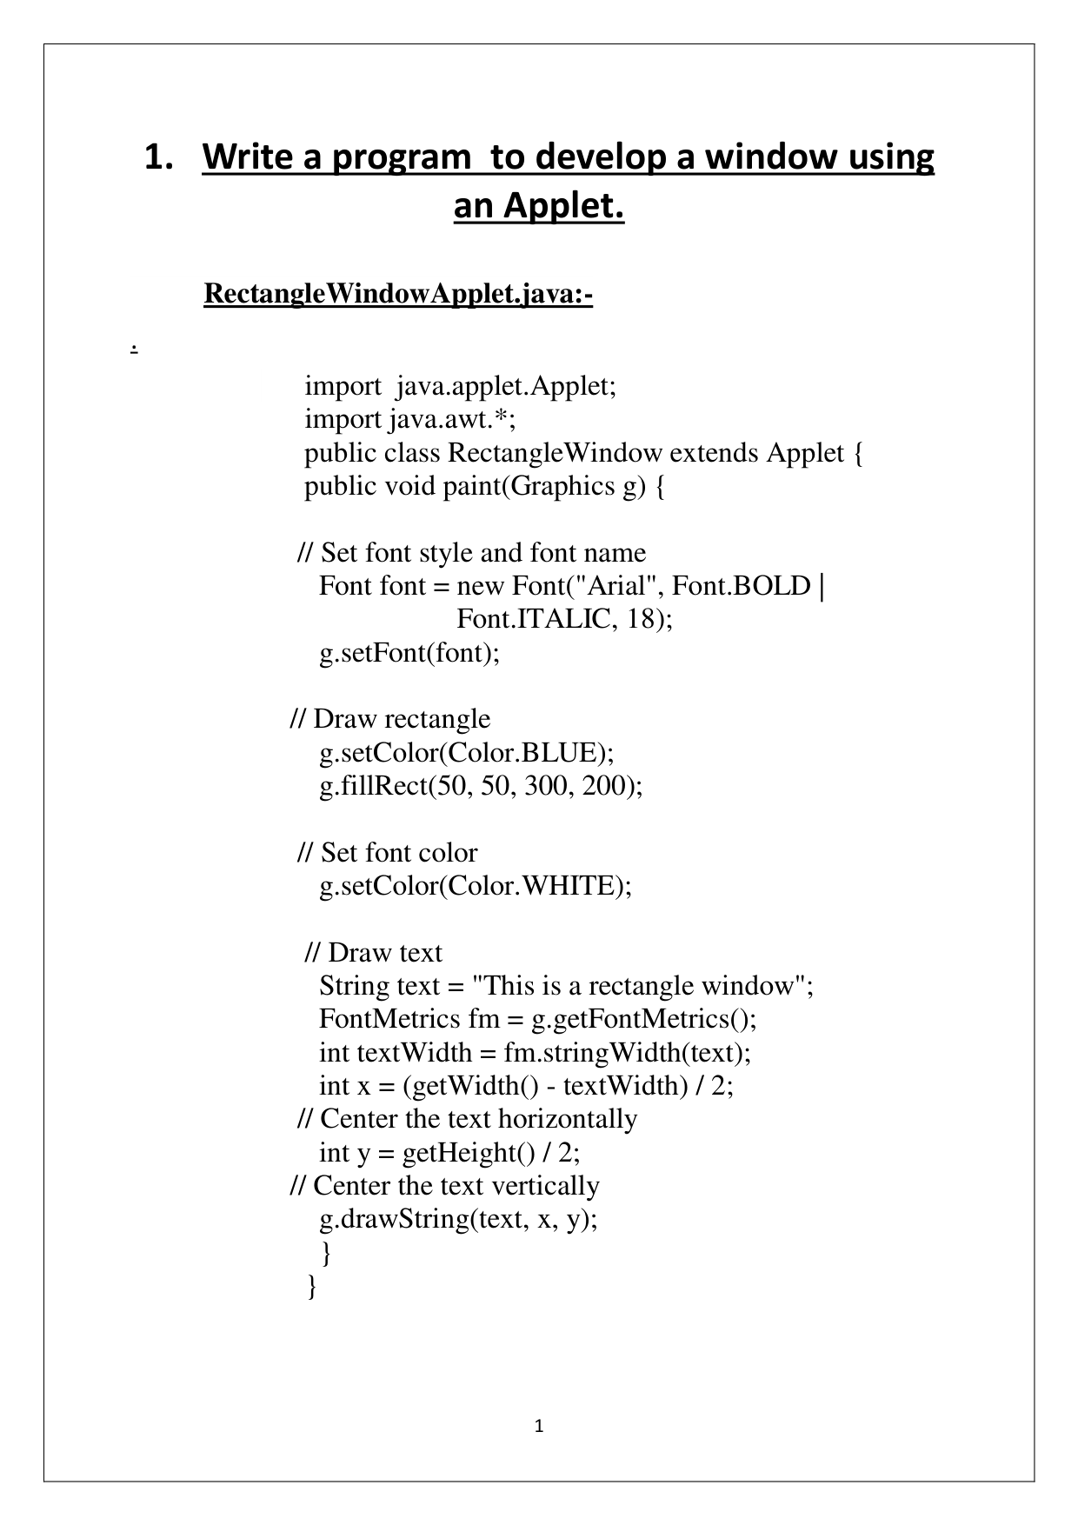

Page 5

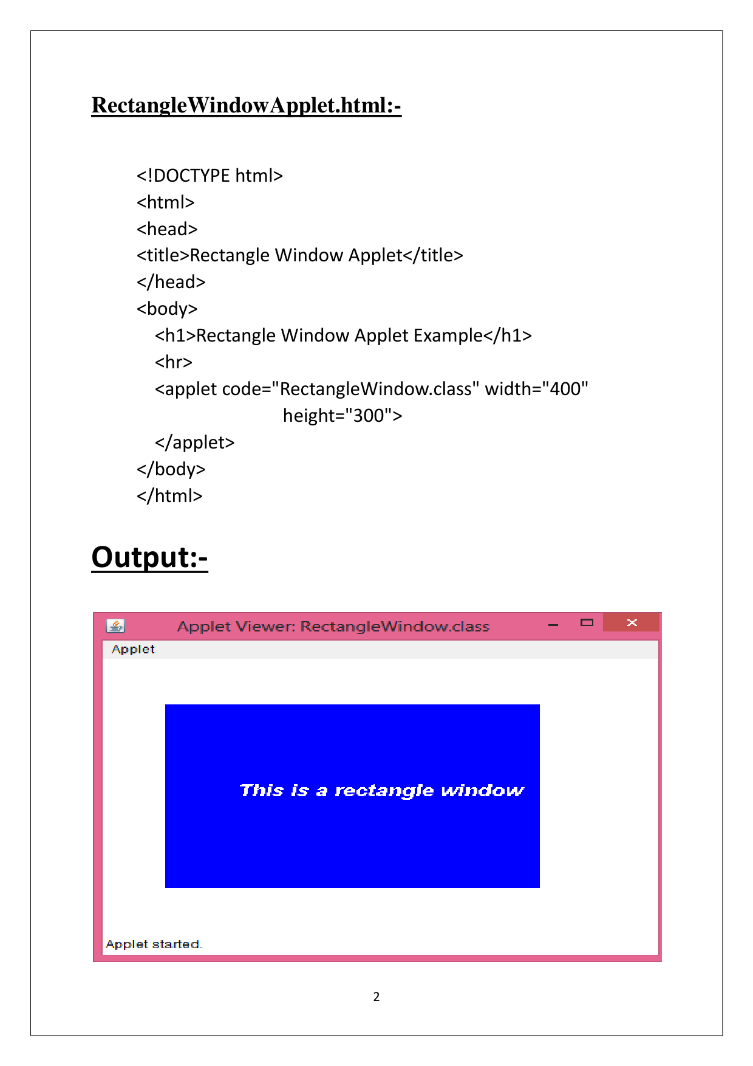

Page 6

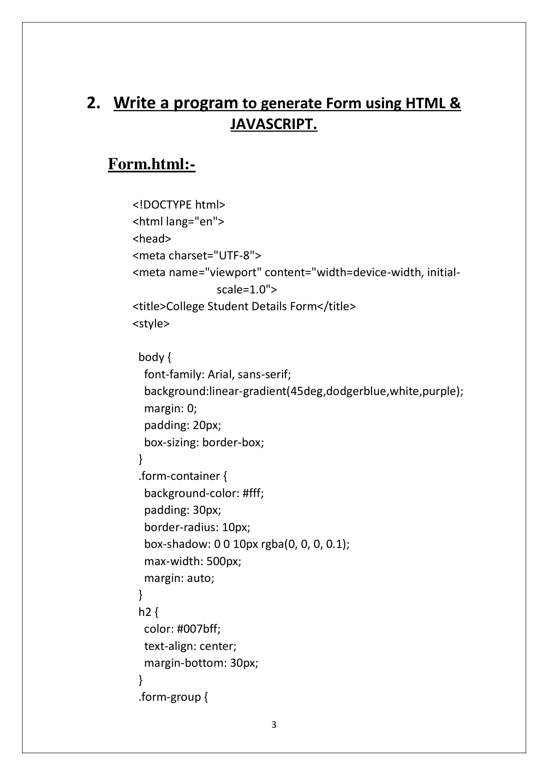

Page 7

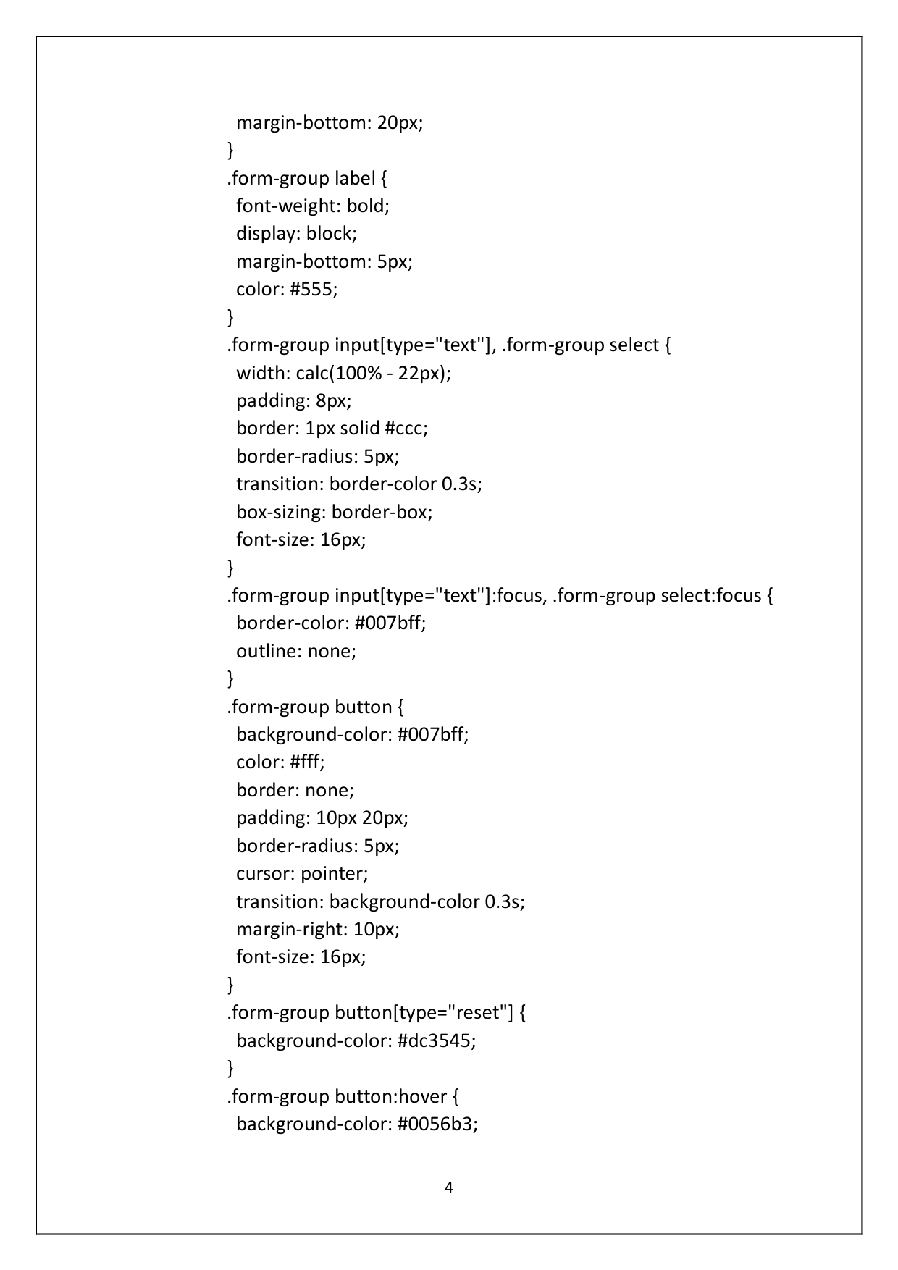

Page 8

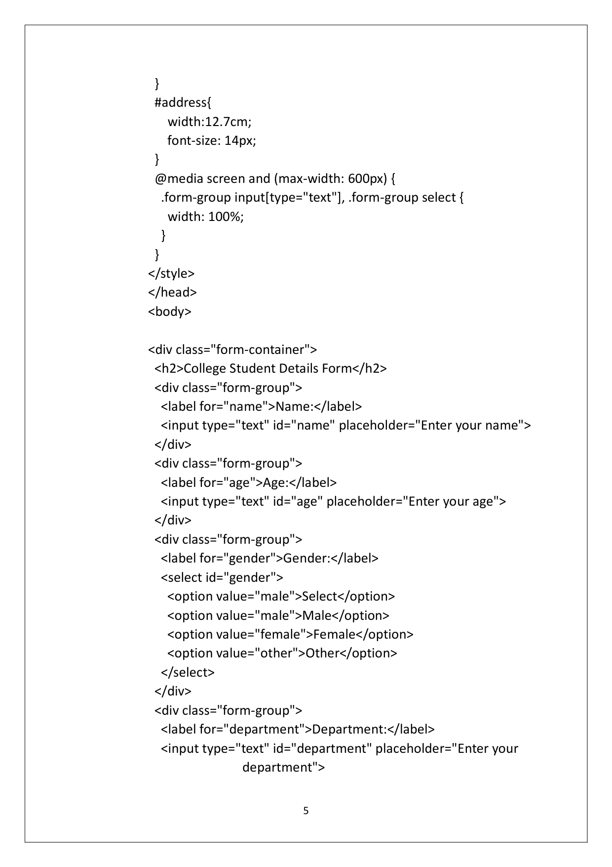

Page 9

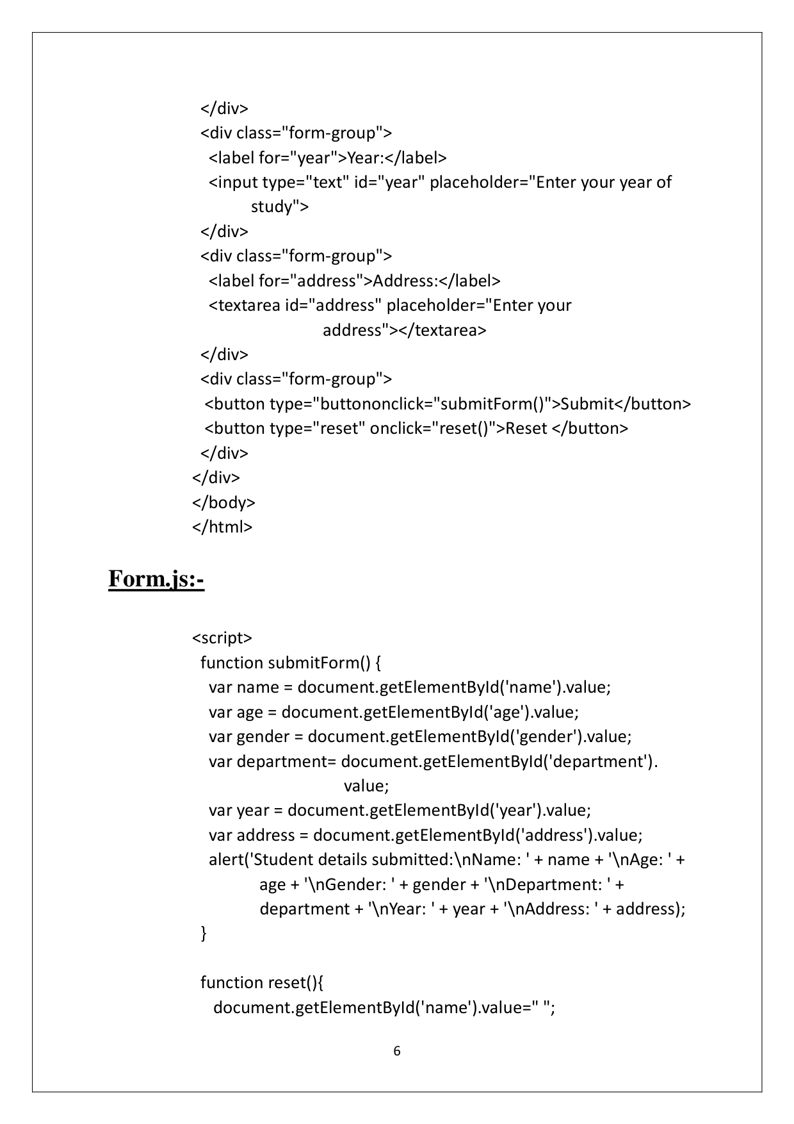

Page 10

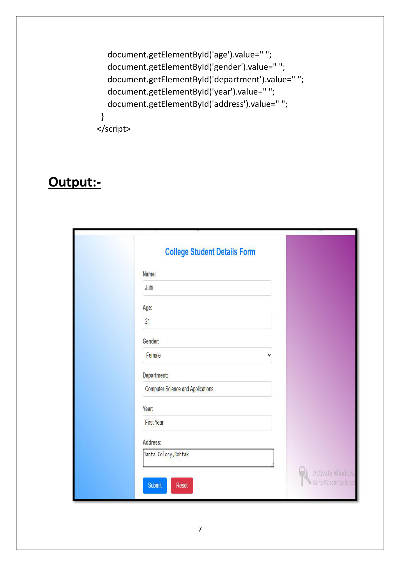

Page 11

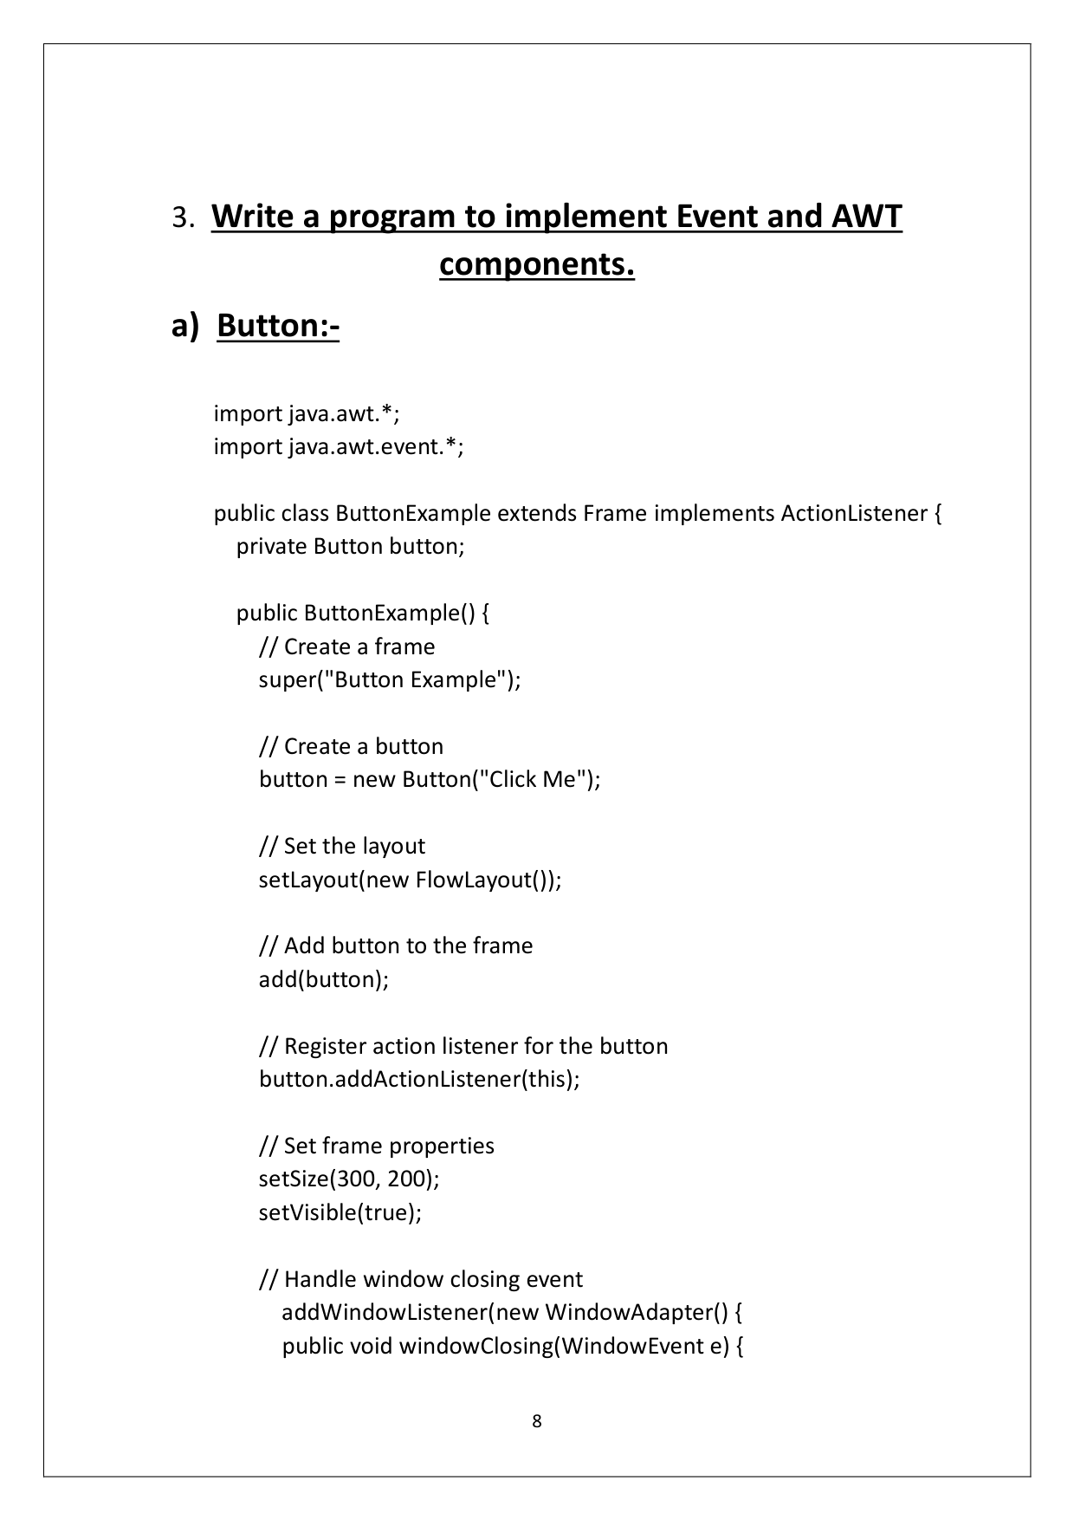

Page 12

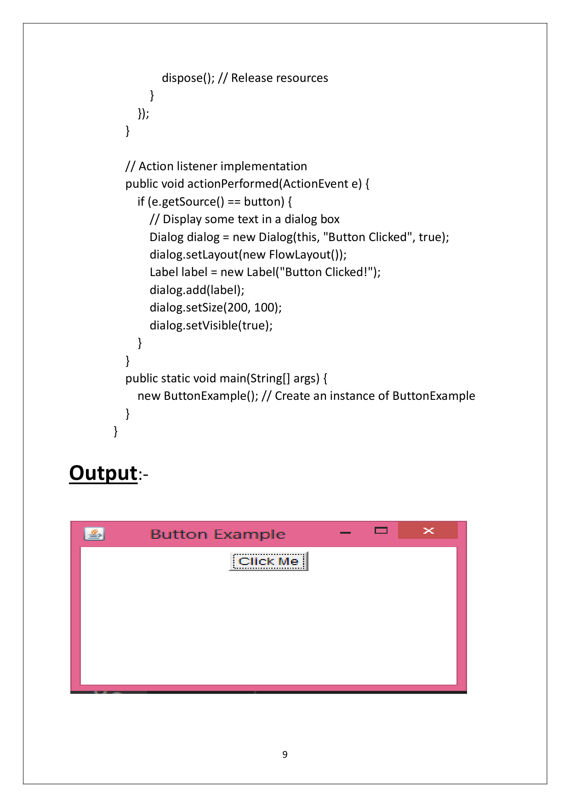

Page 13

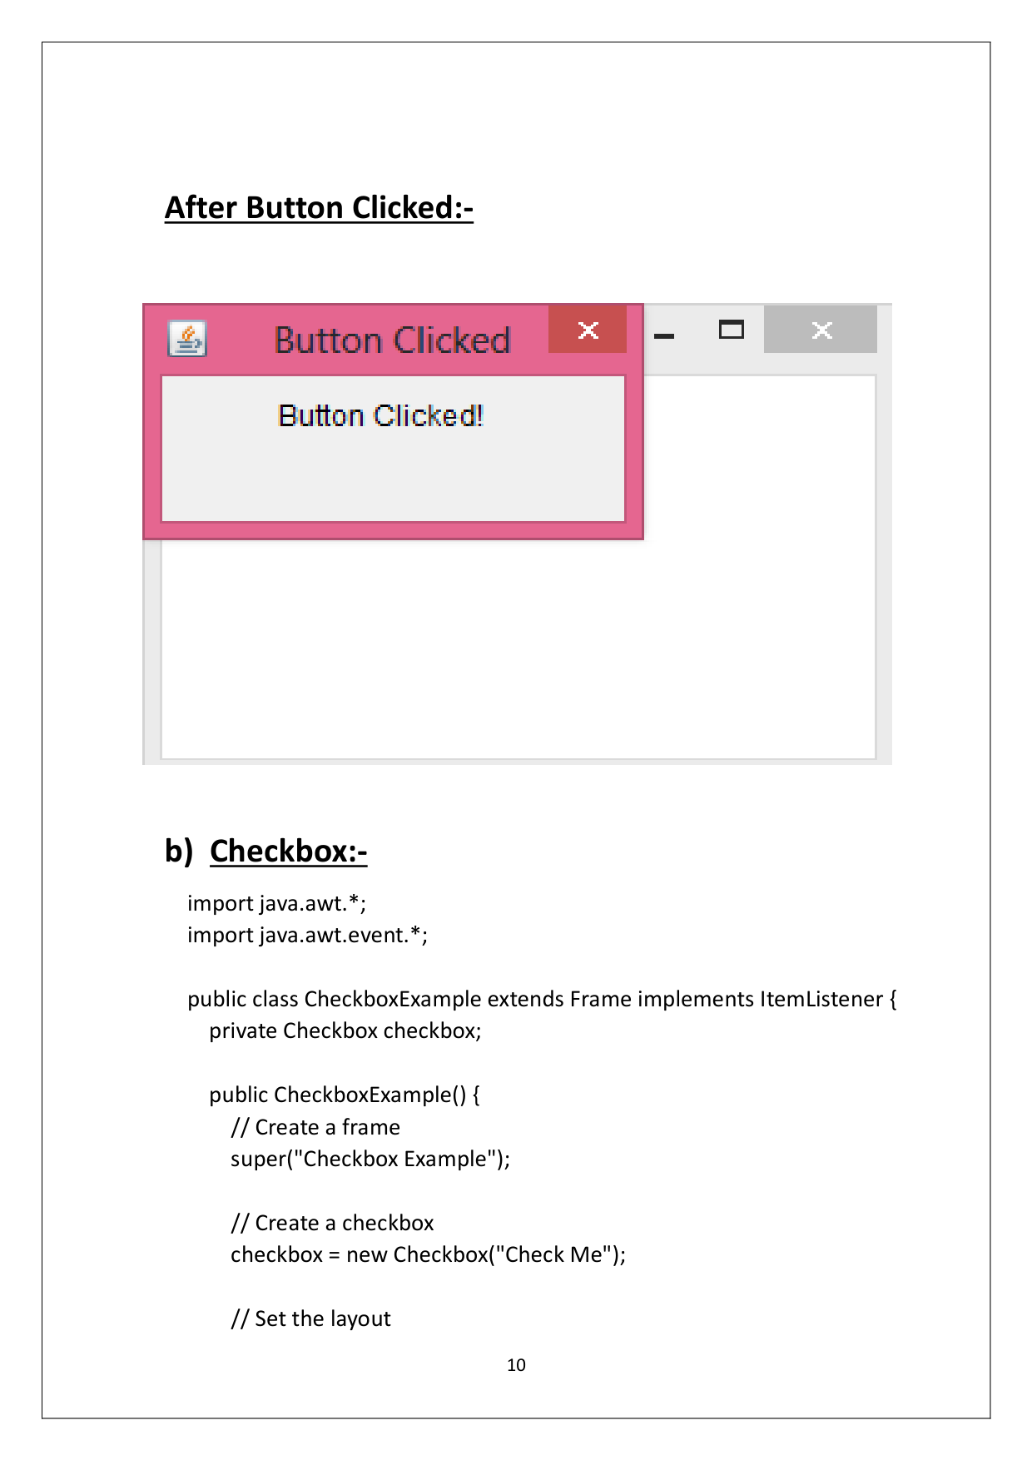

Page 14

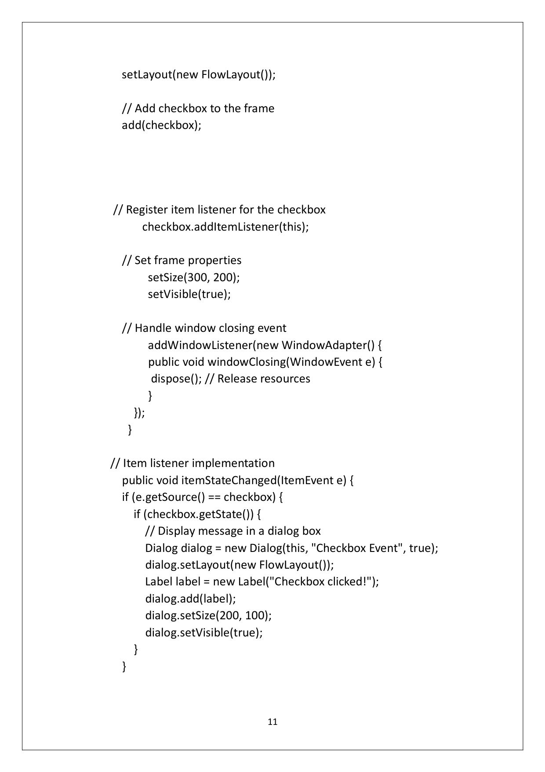

Page 15

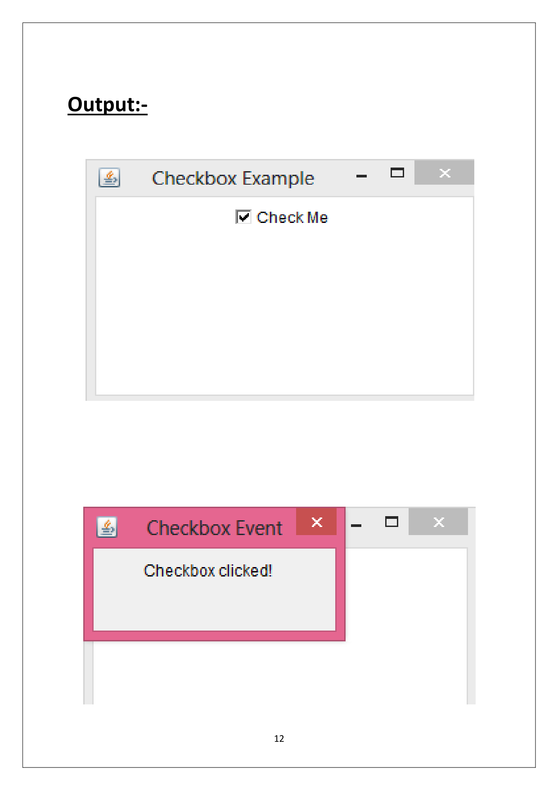

Page 16

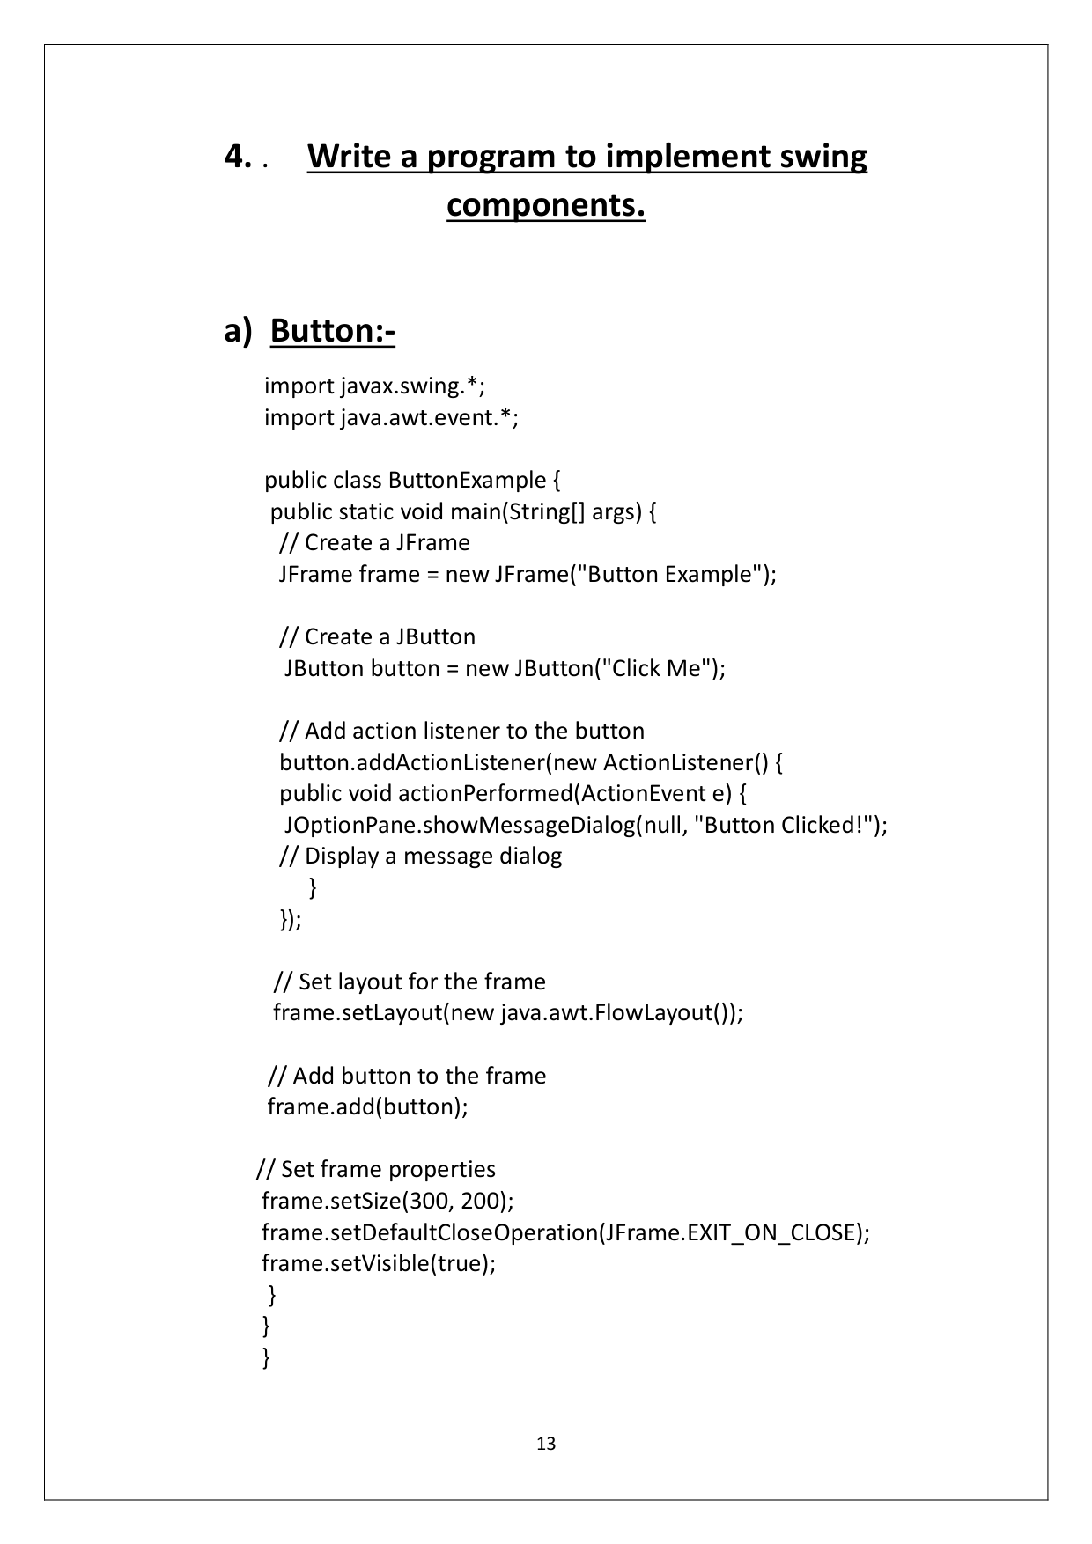

Page 17

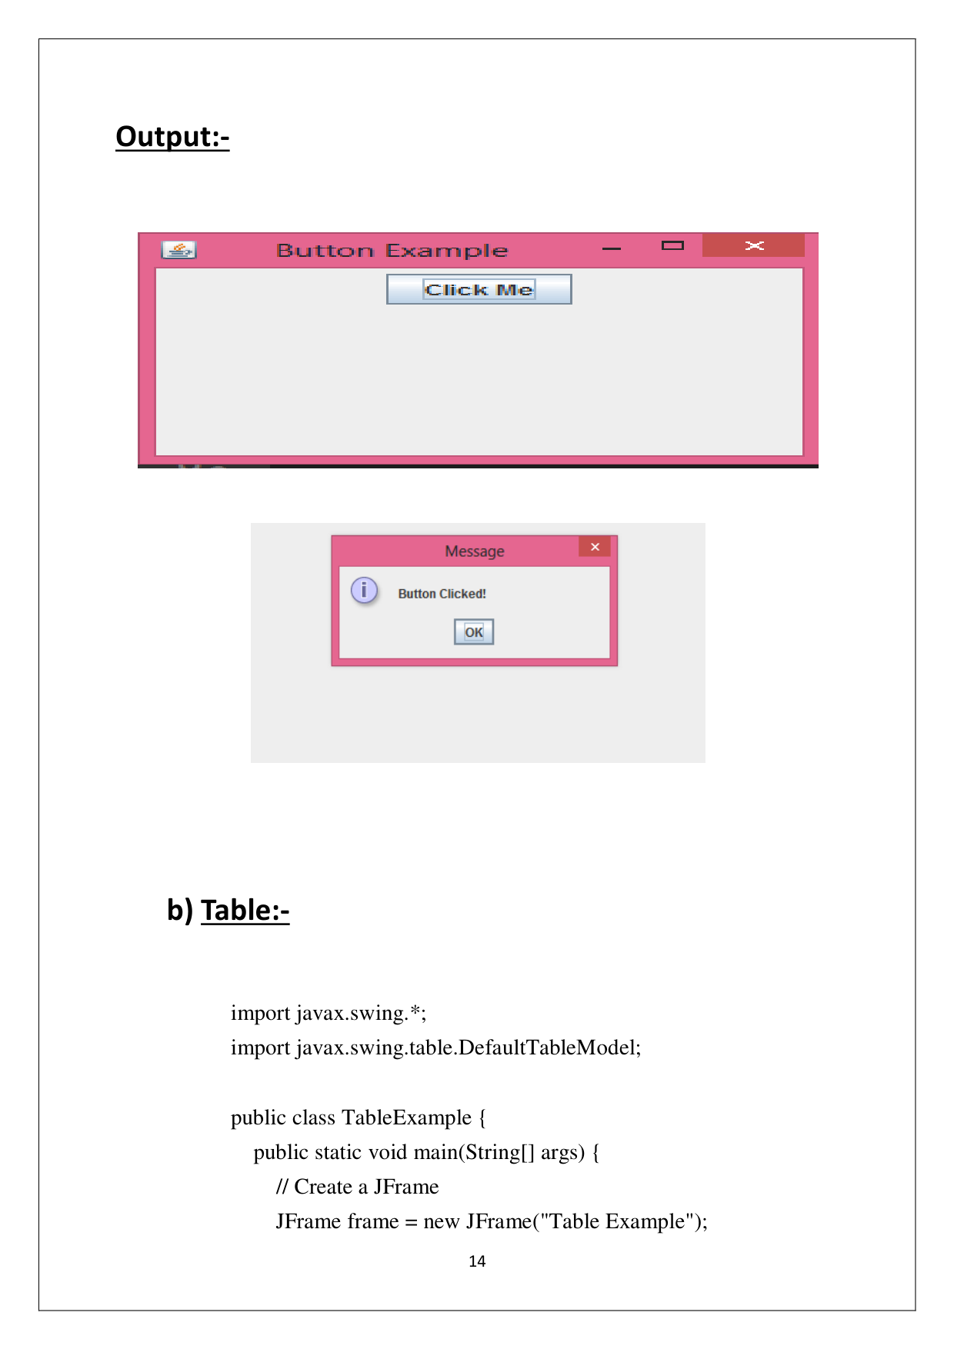

Page 18

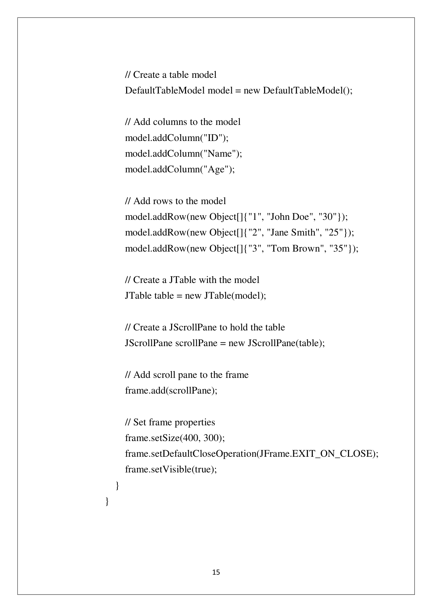

Page 19

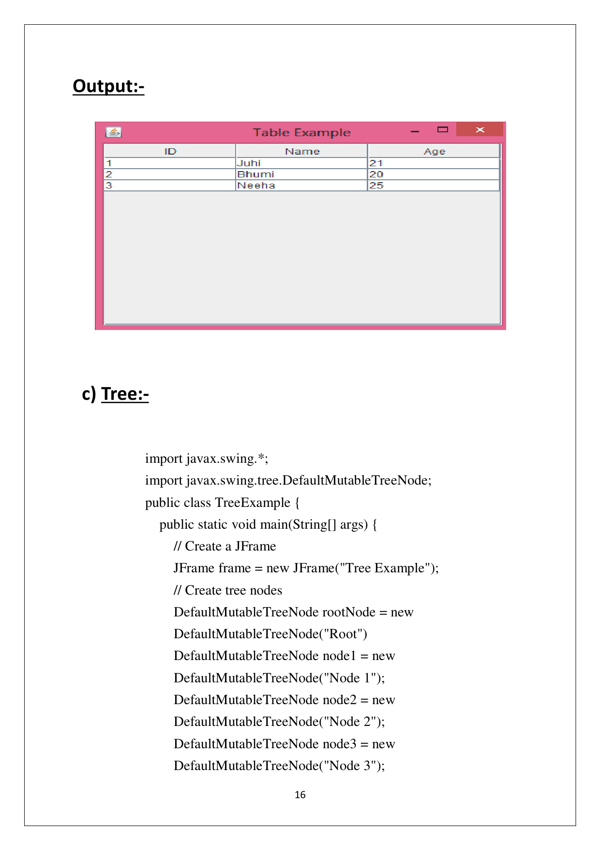

Page 20

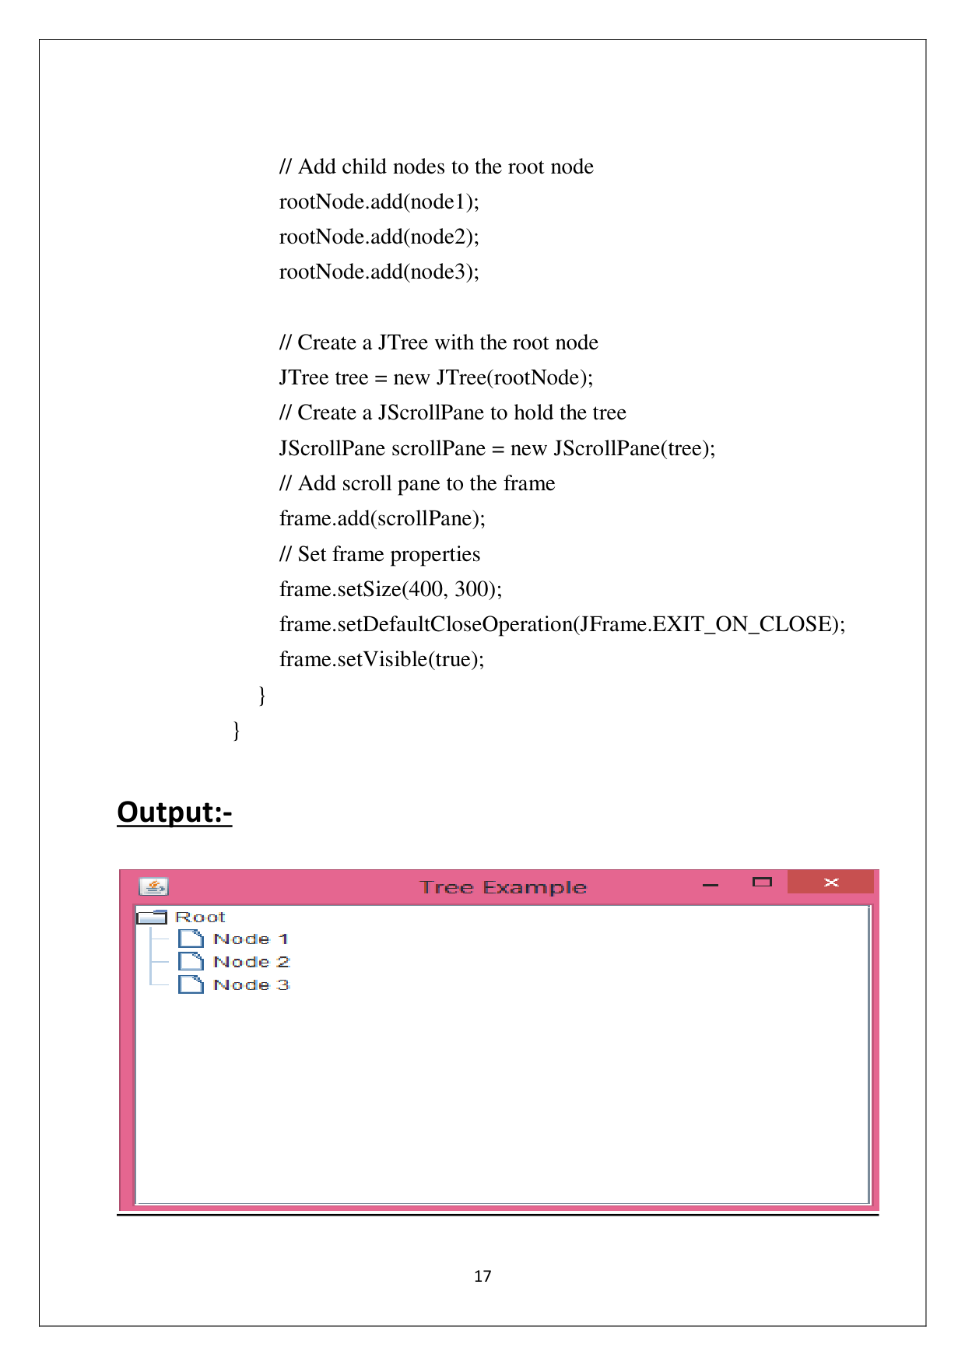

Page 21

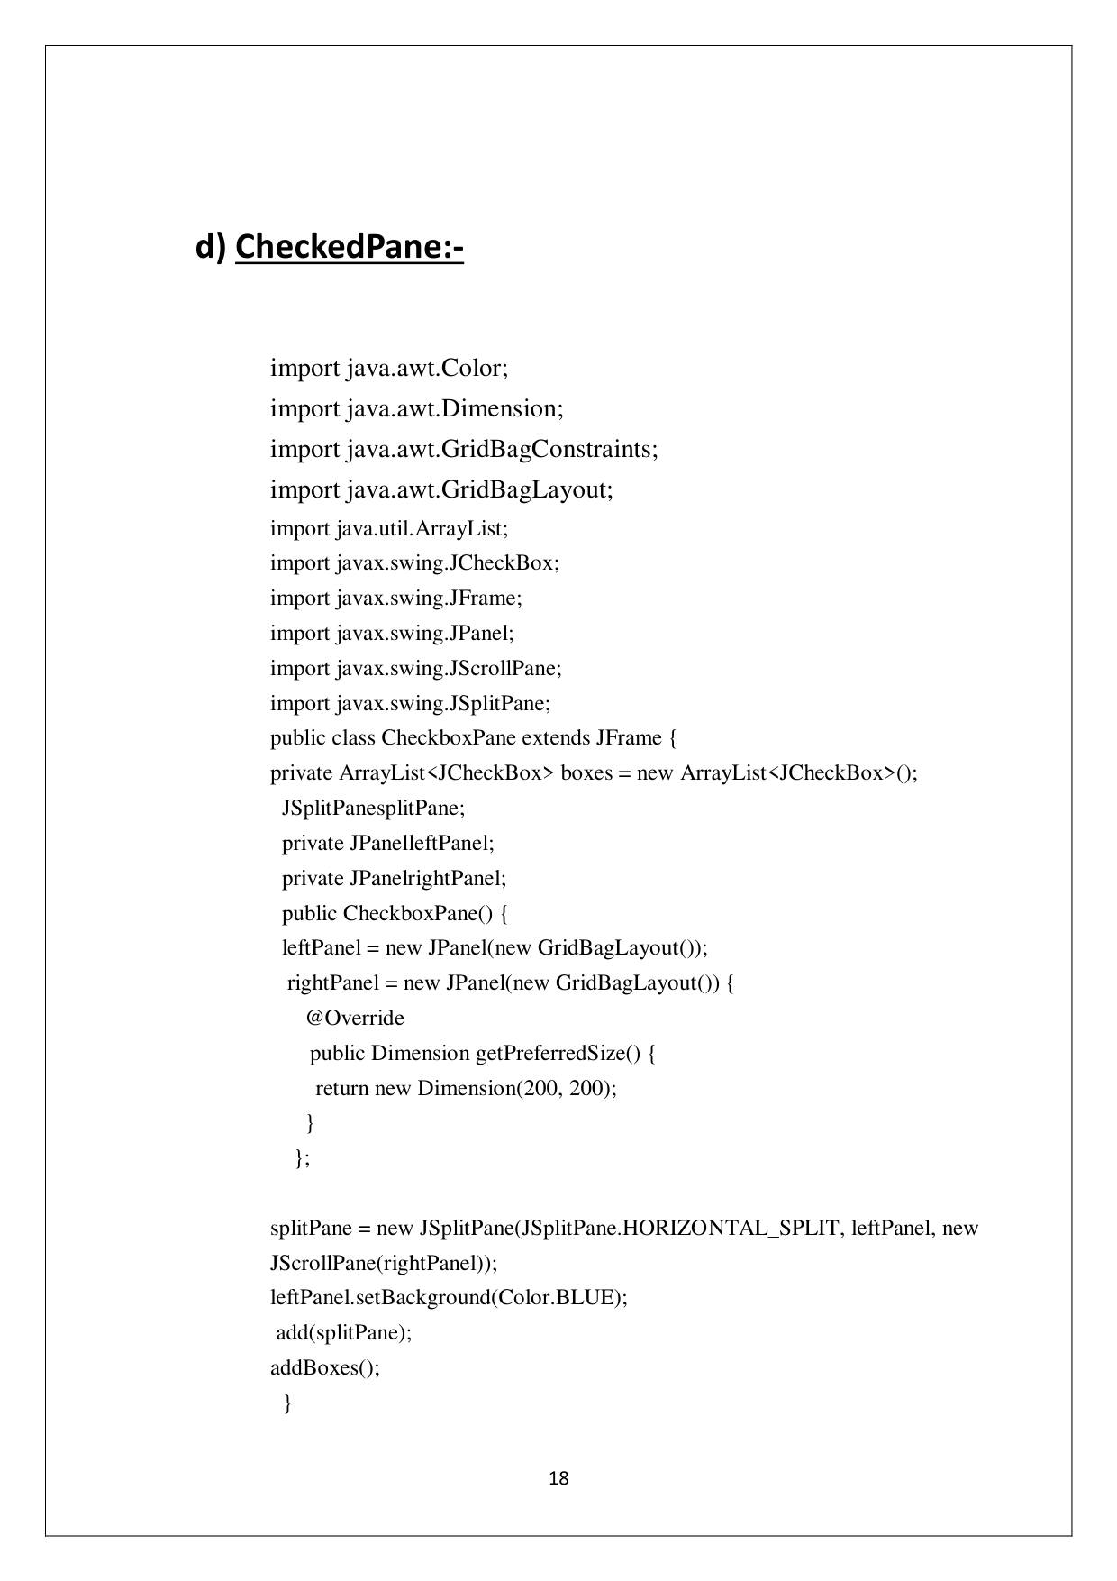

Page 22

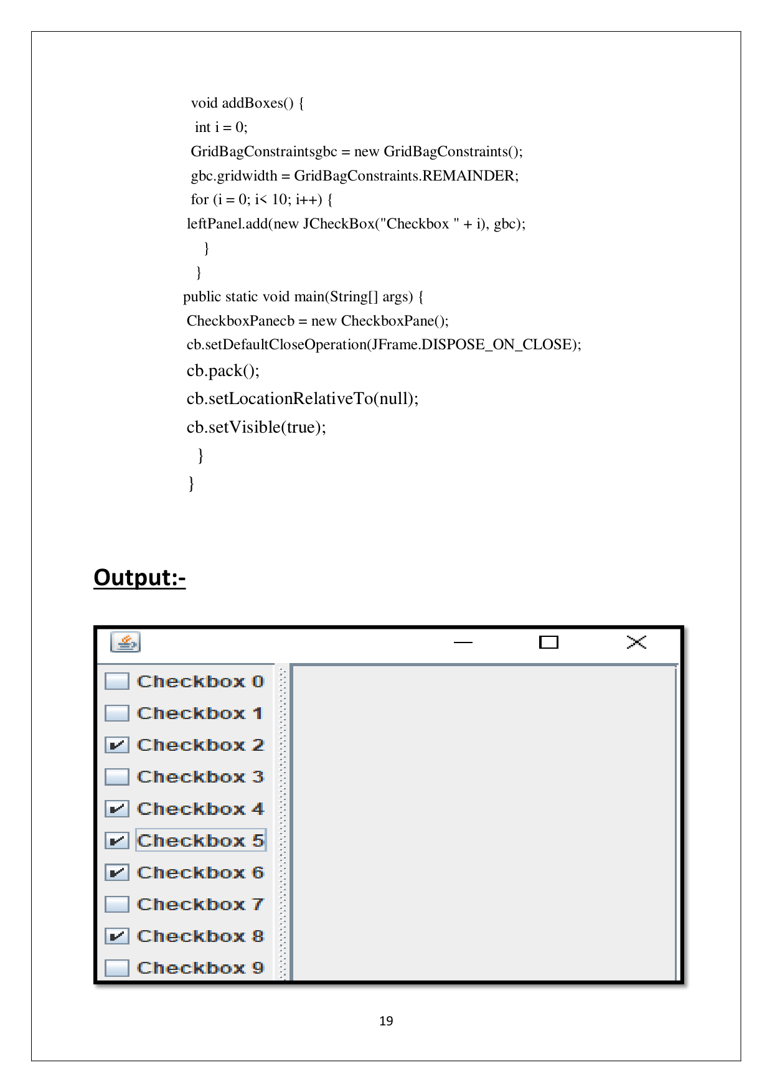

Page 23

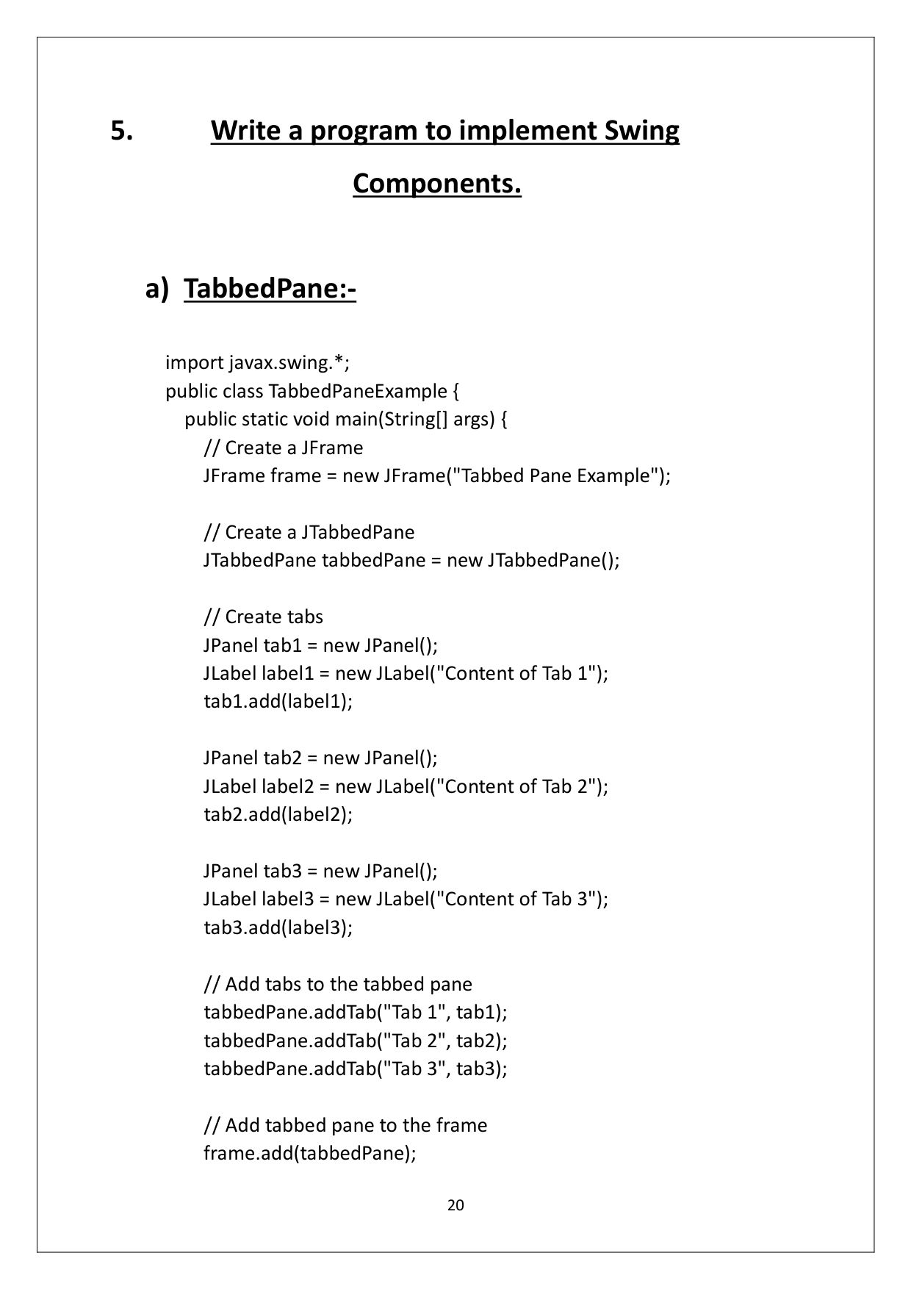

Page 24

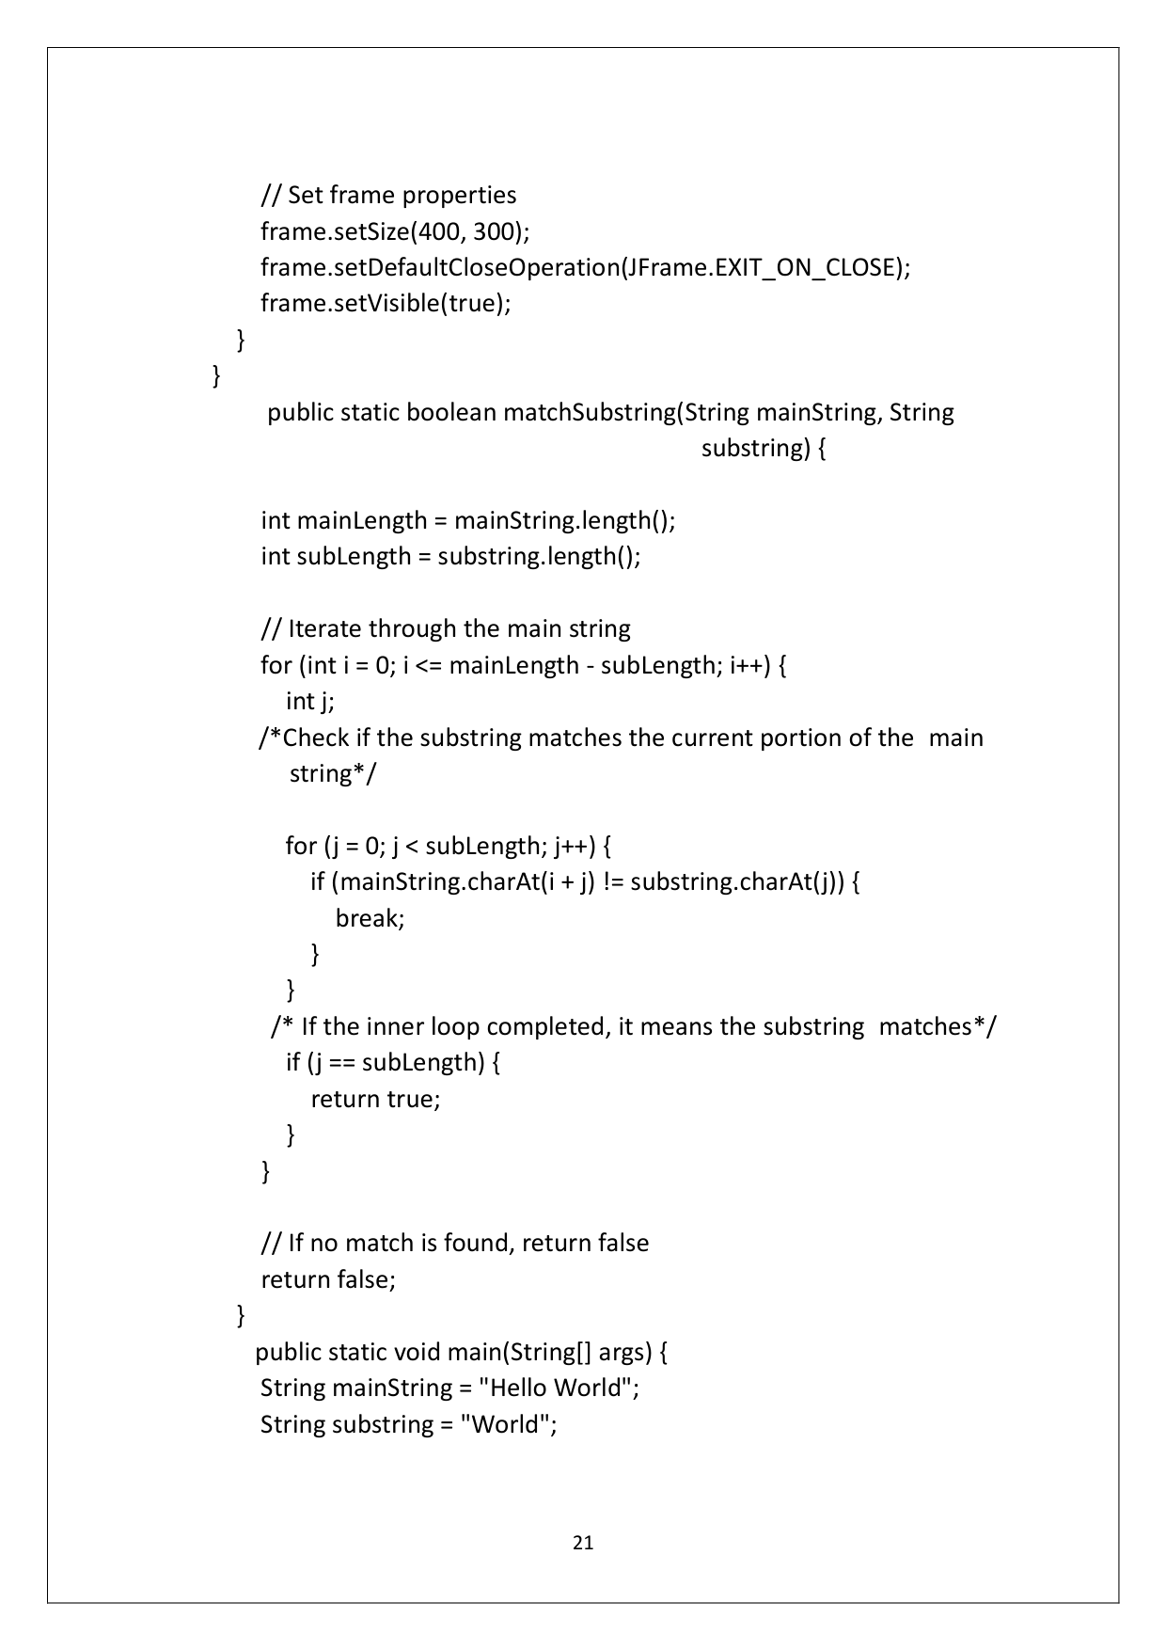

Page 25

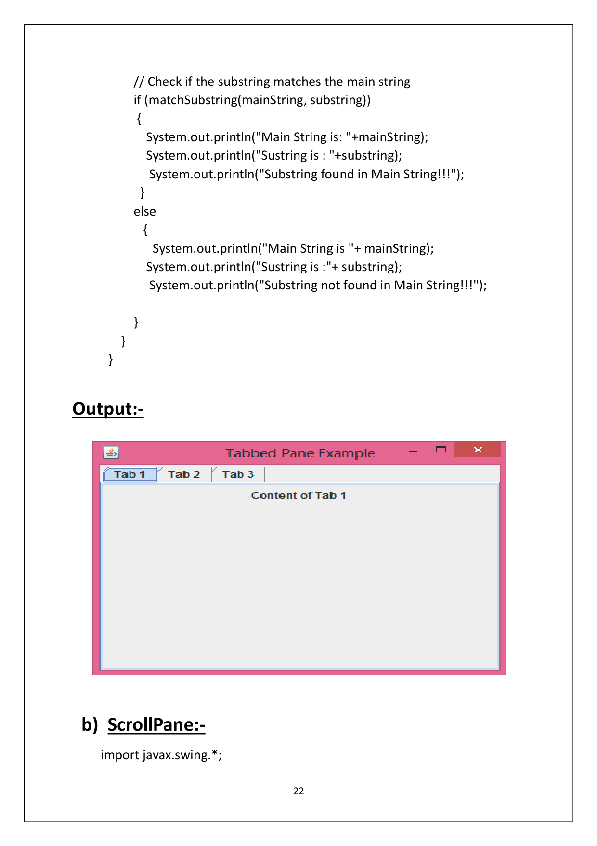

Page 26

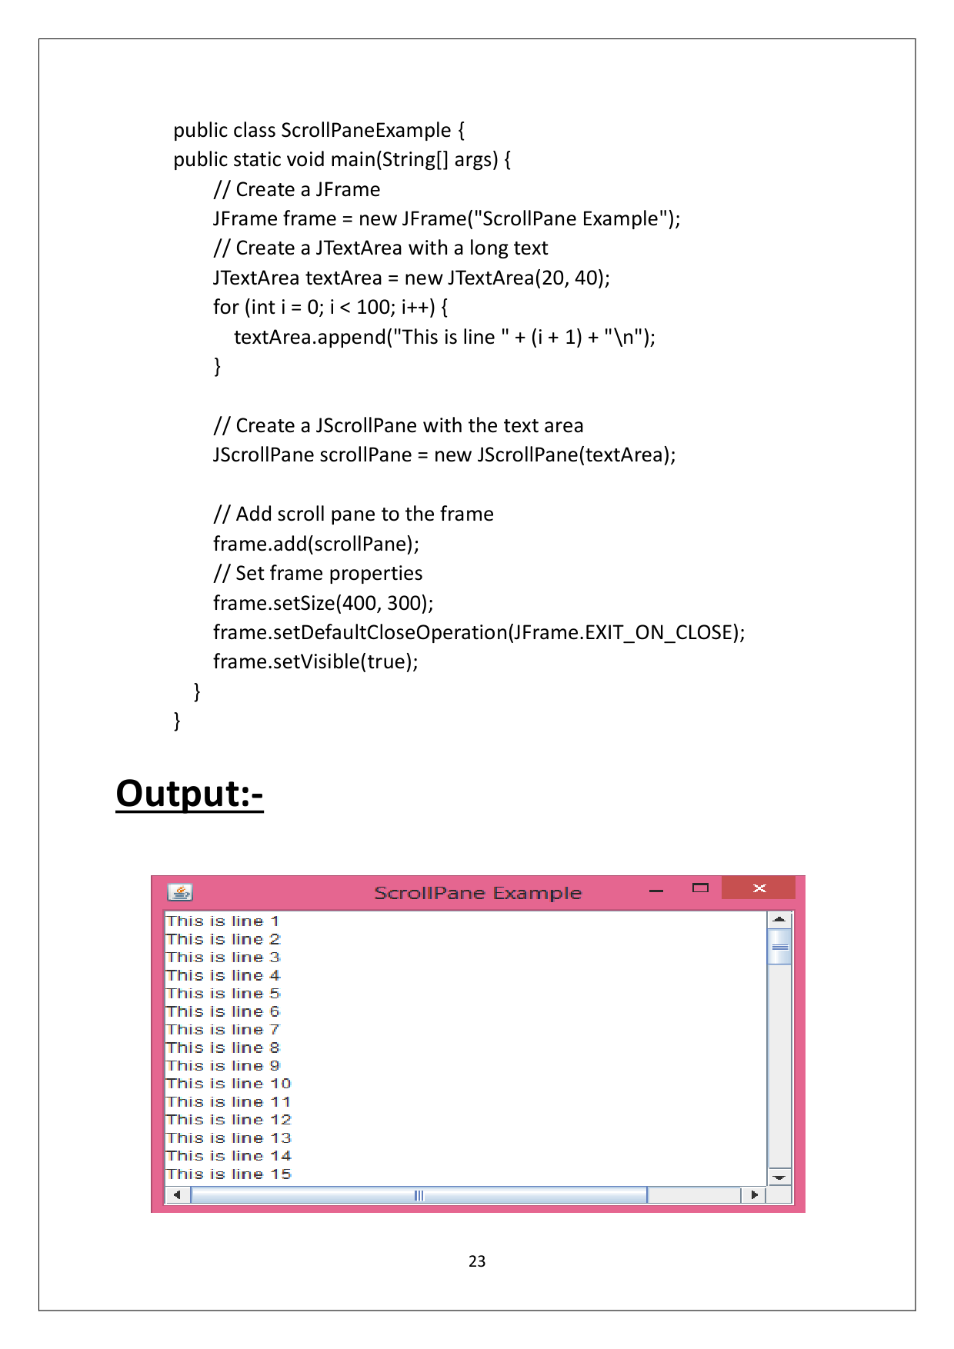

Page 27

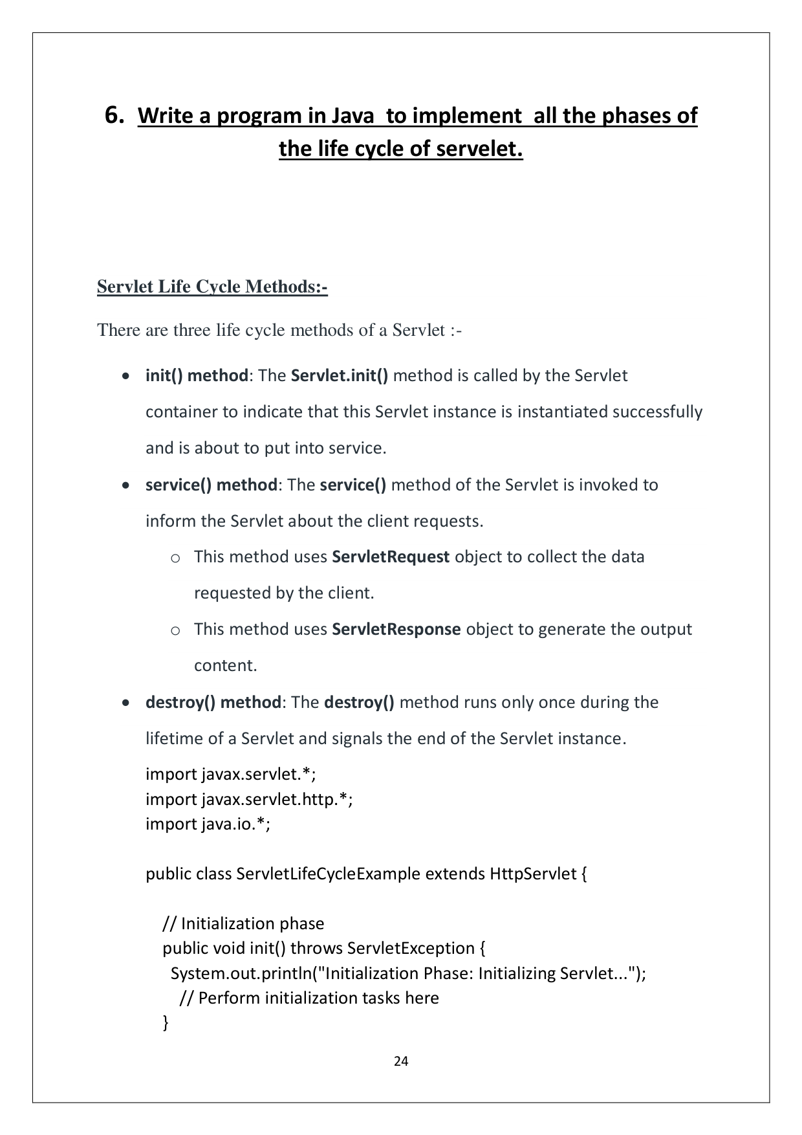

Page 28

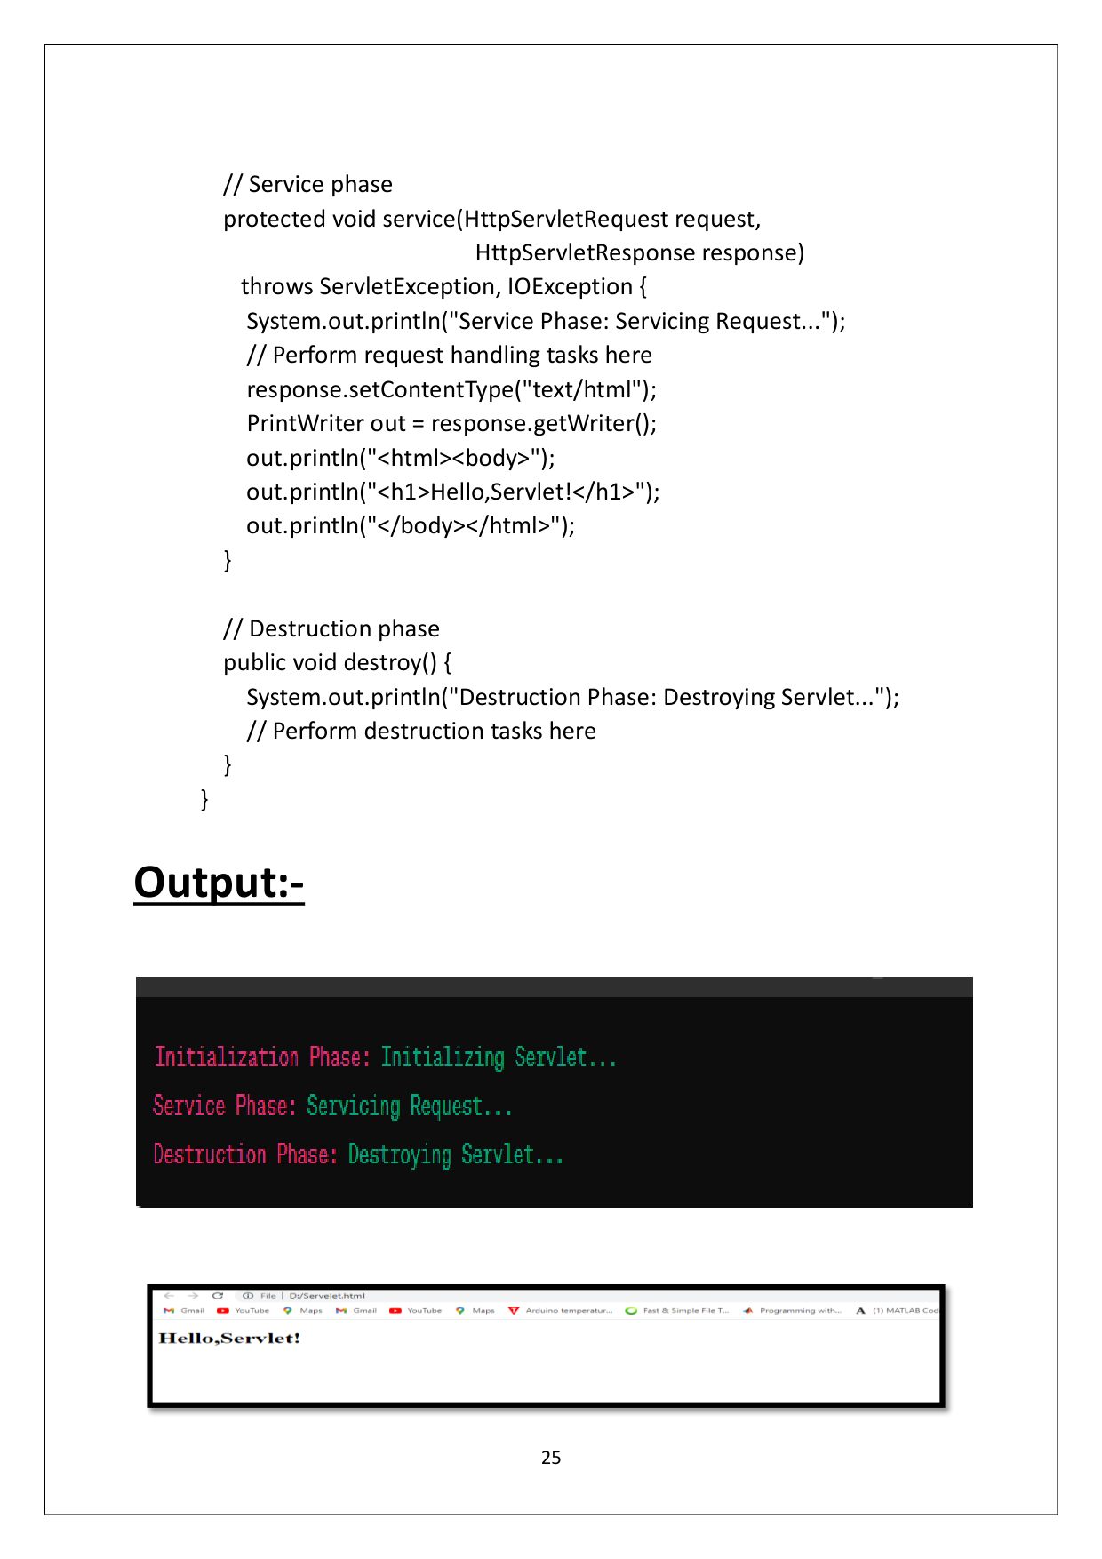

Page 29

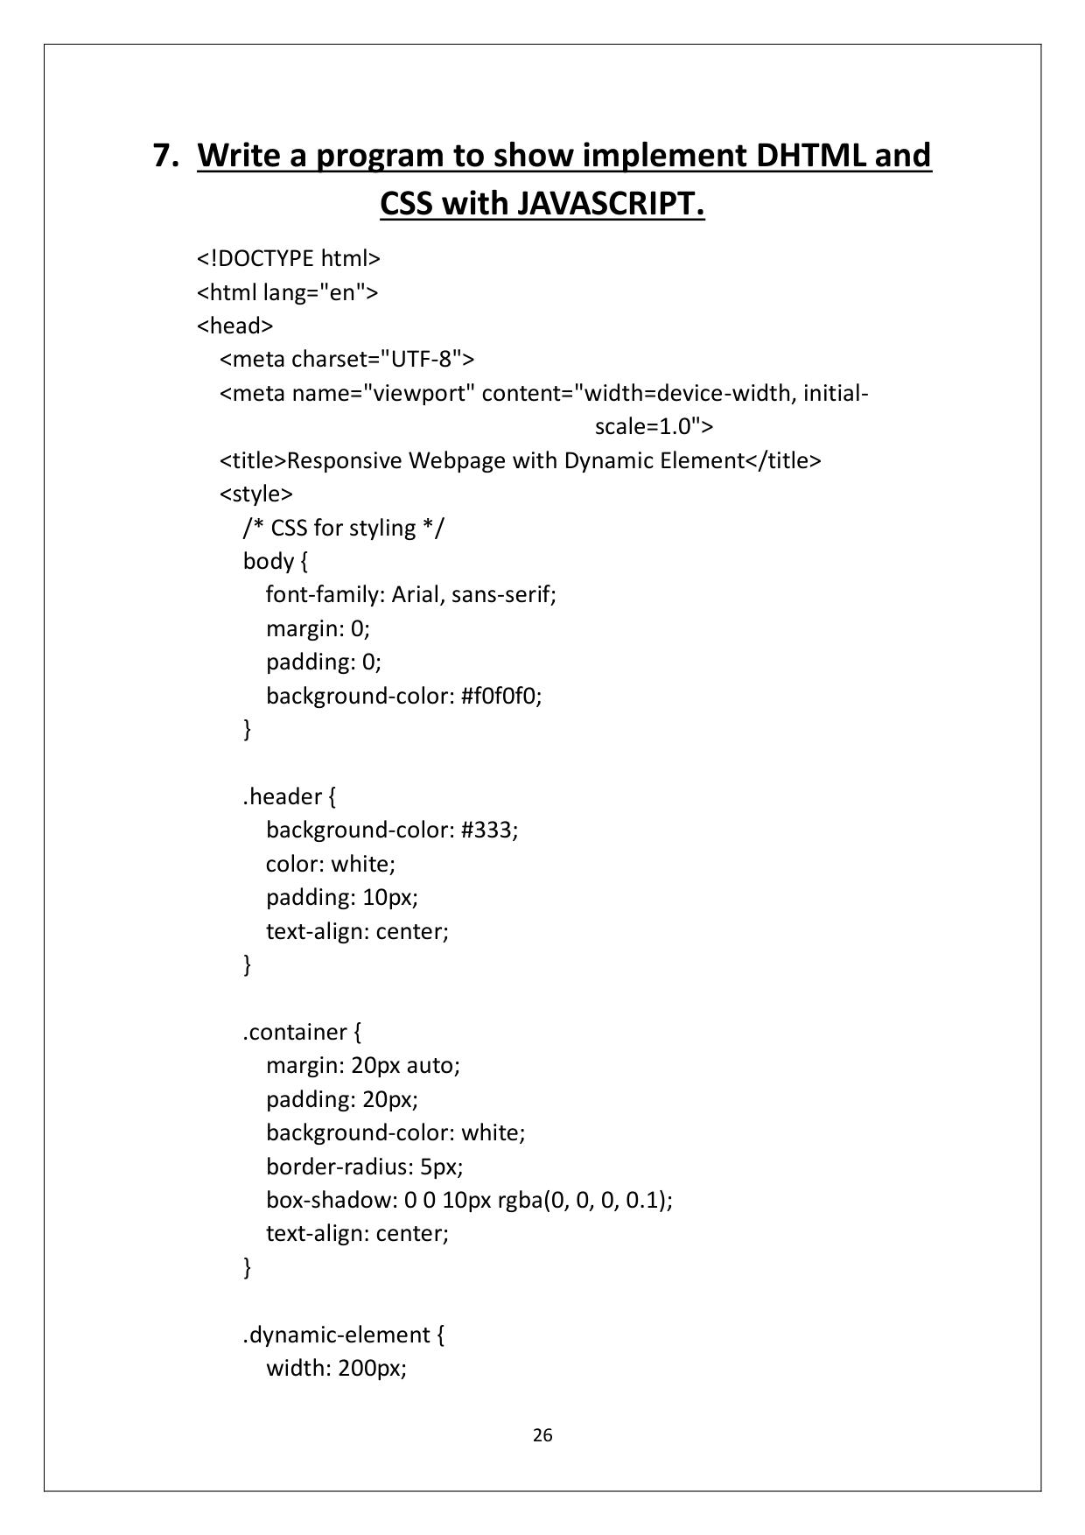

Page 30

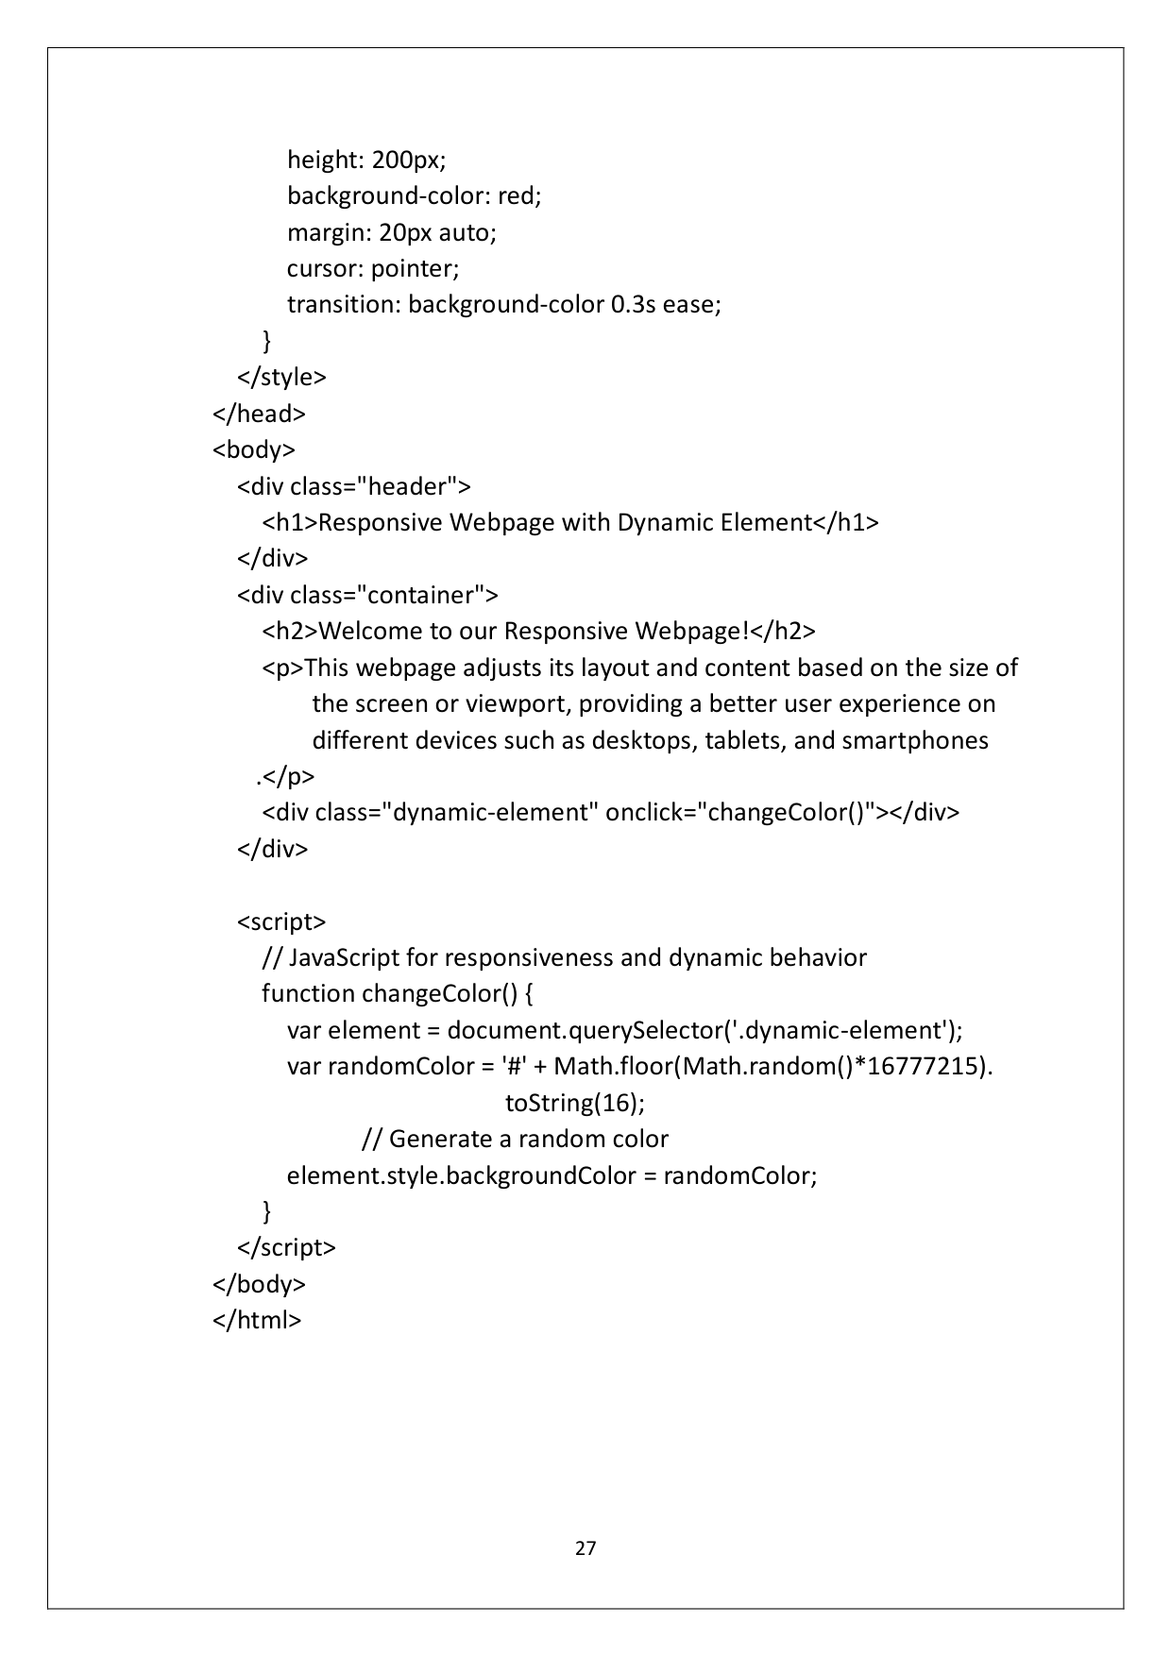

Page 31

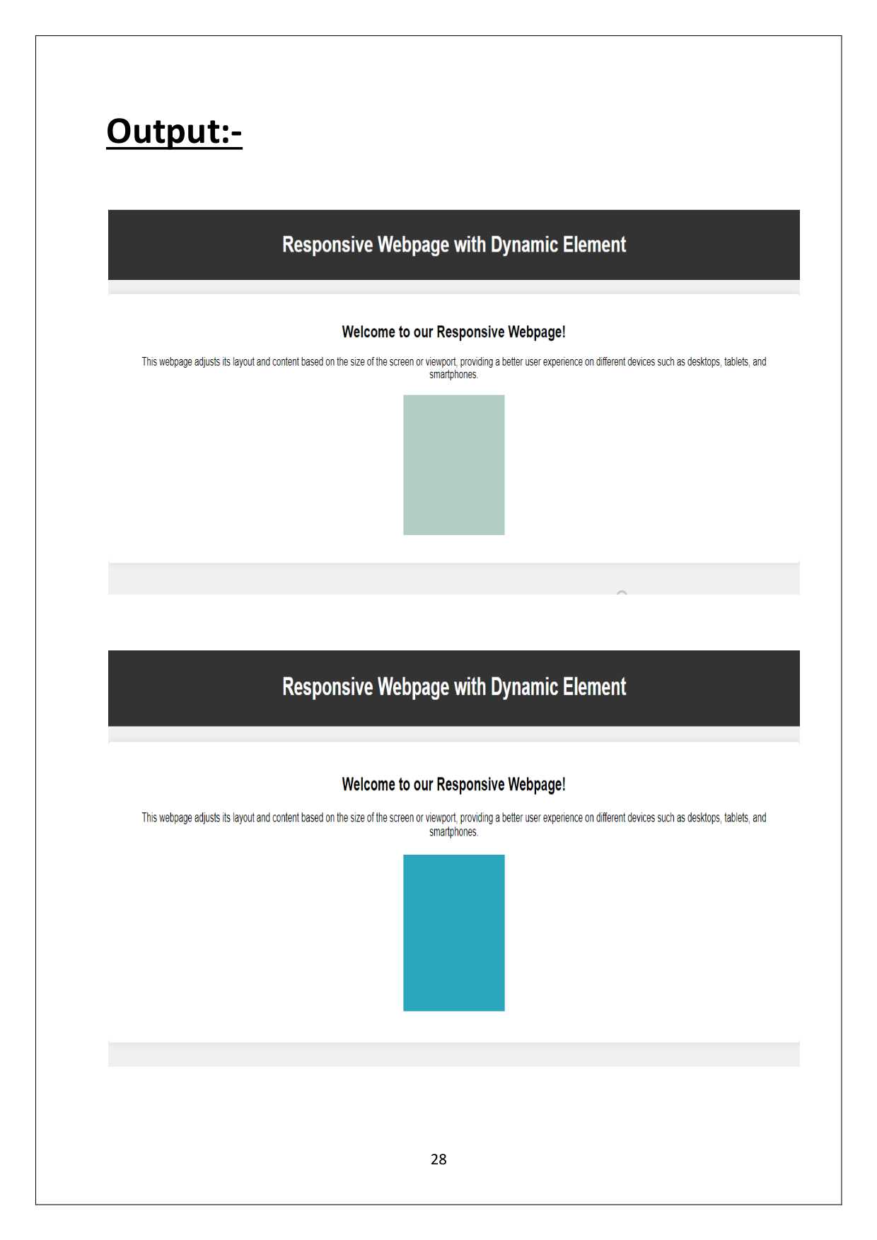

Page 32

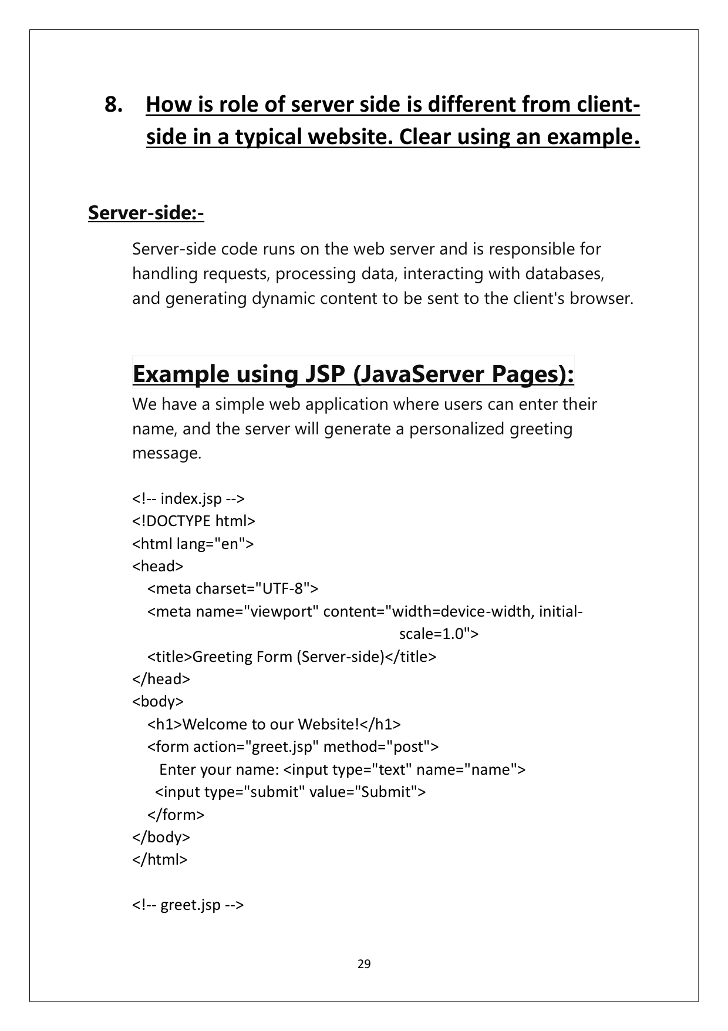

Page 33

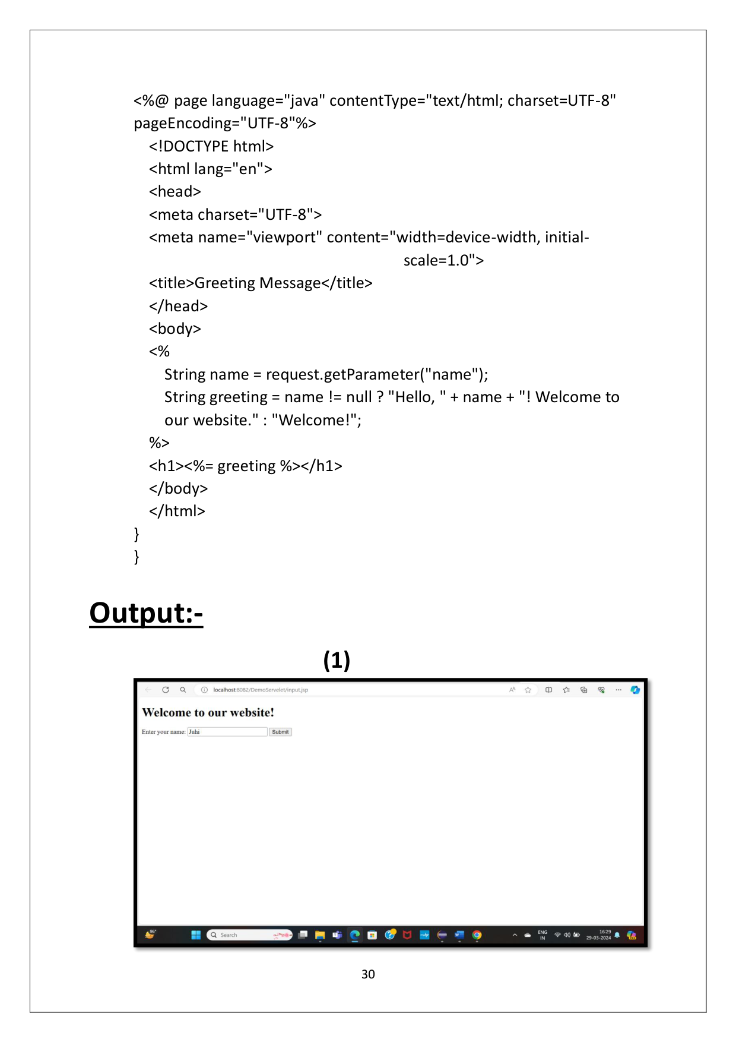

Page 34

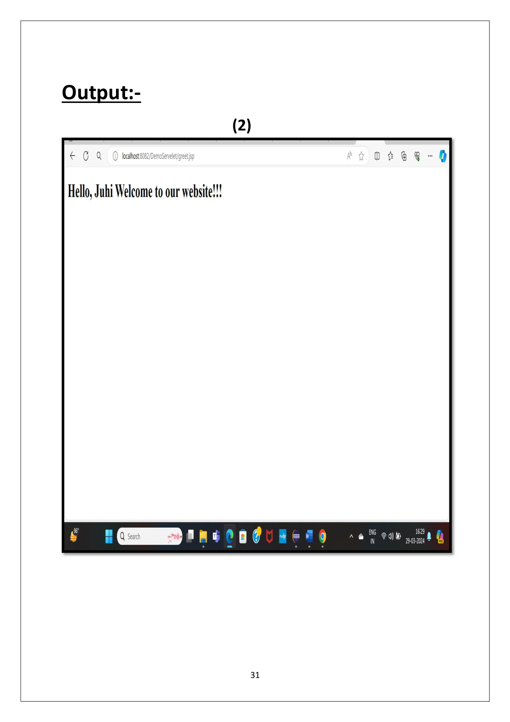

Page 35

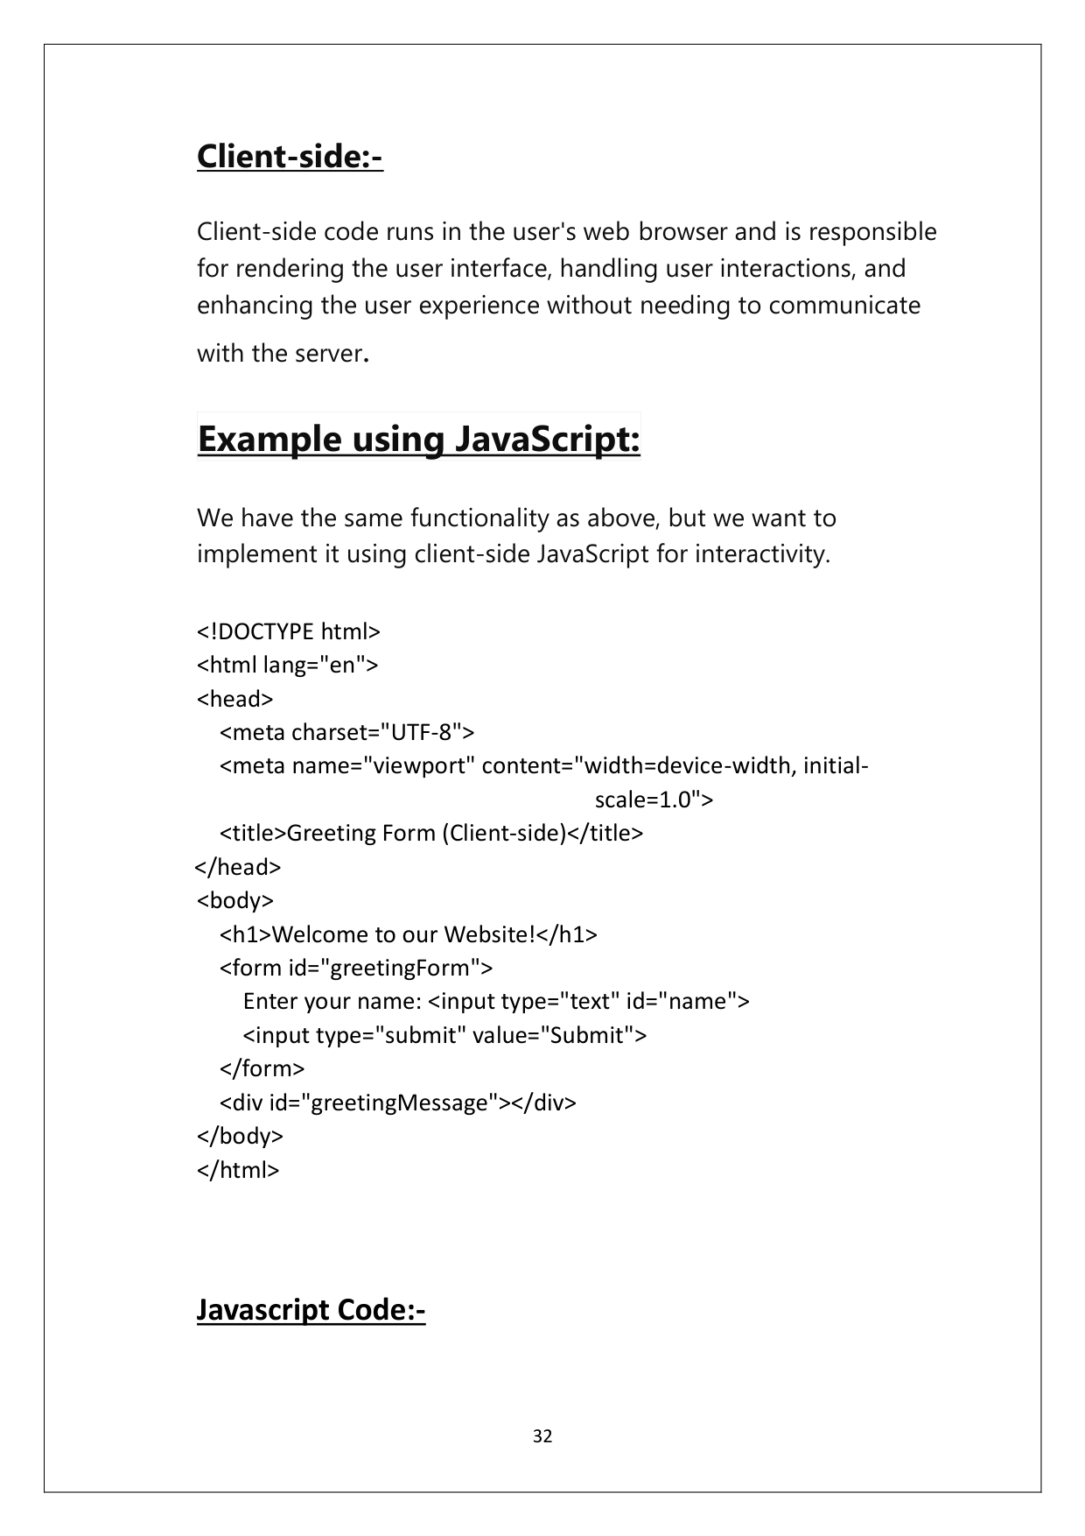

Page 36

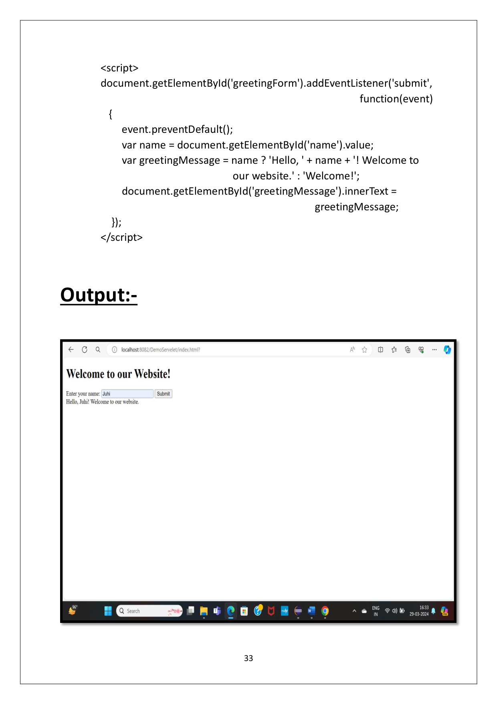

Page 37

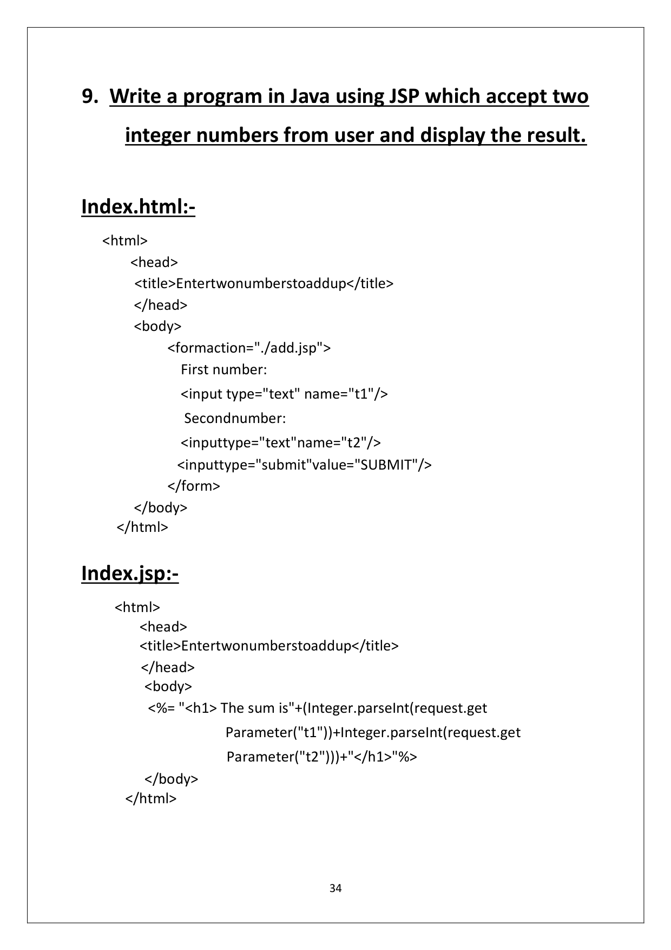

Page 38

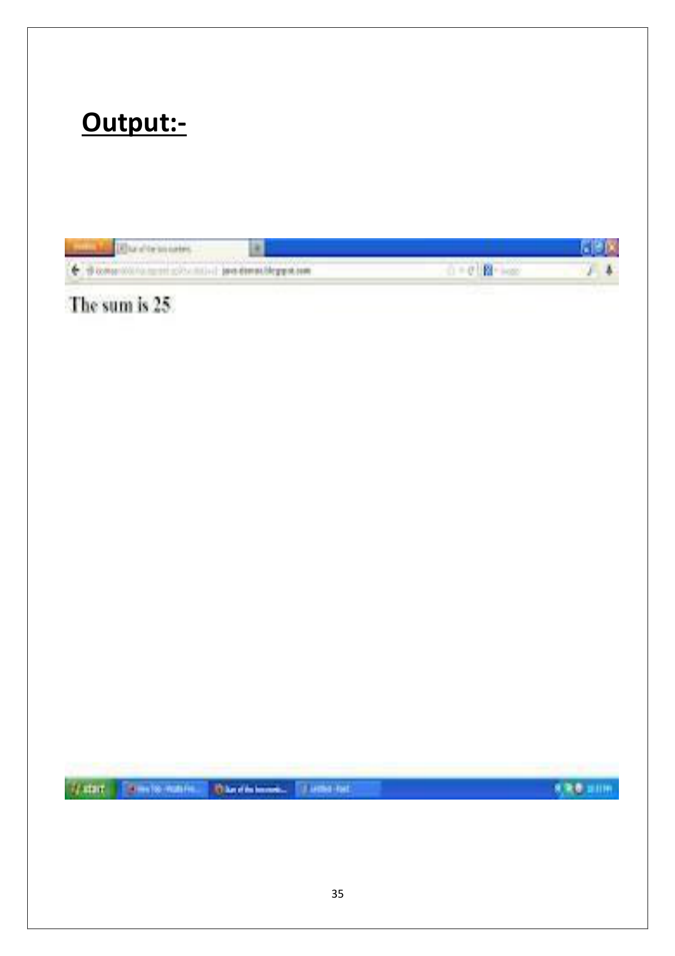

Page 39

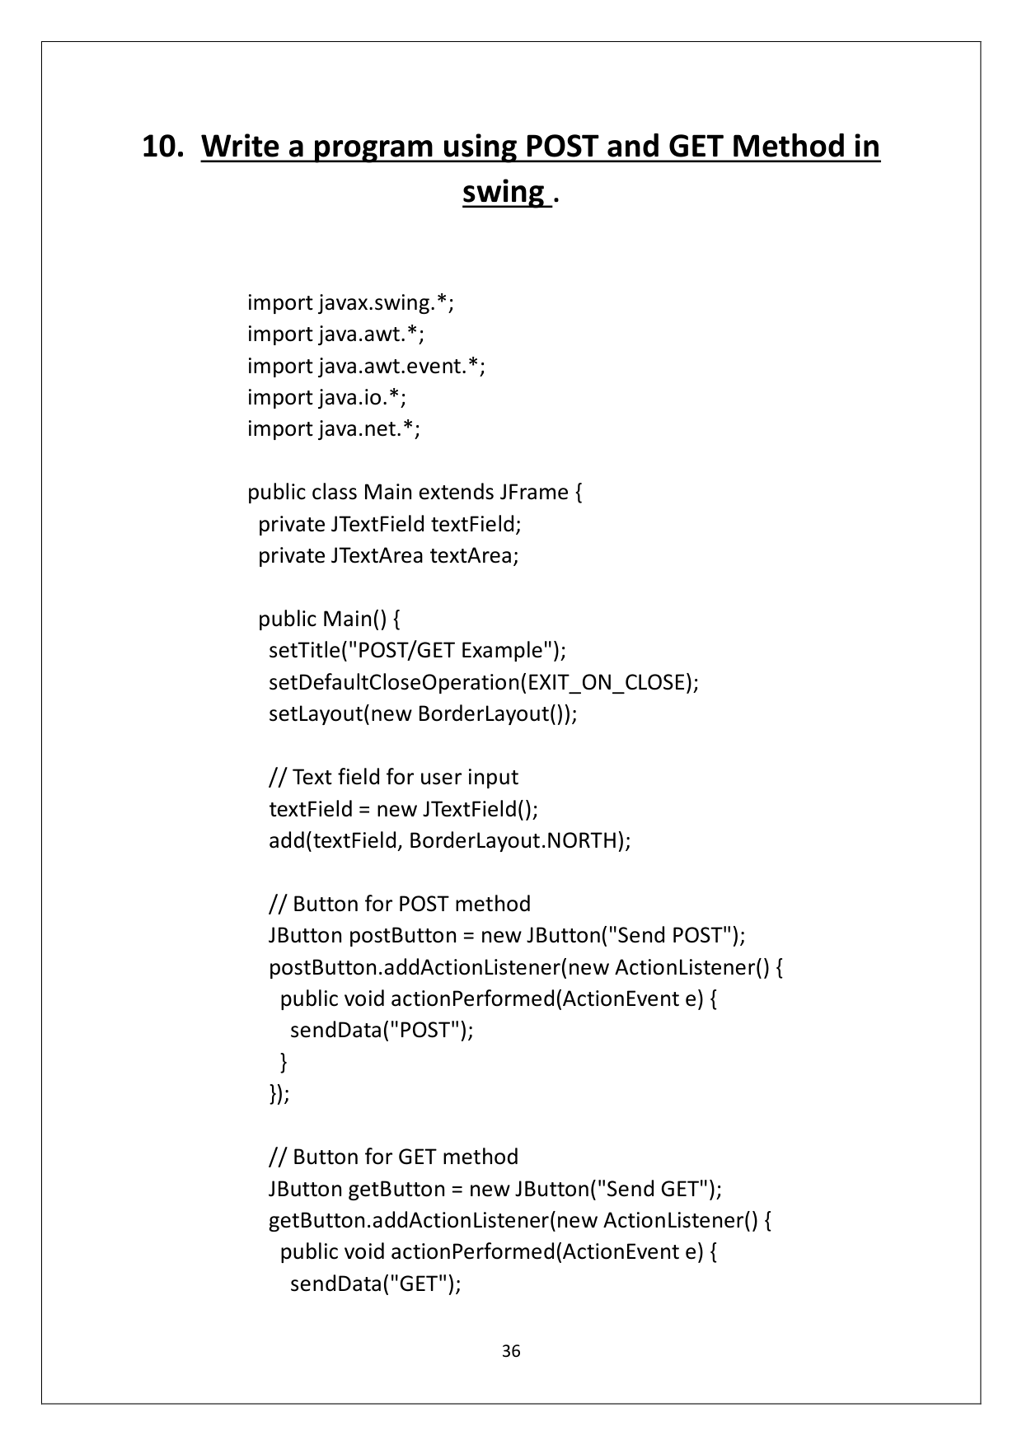

Page 40

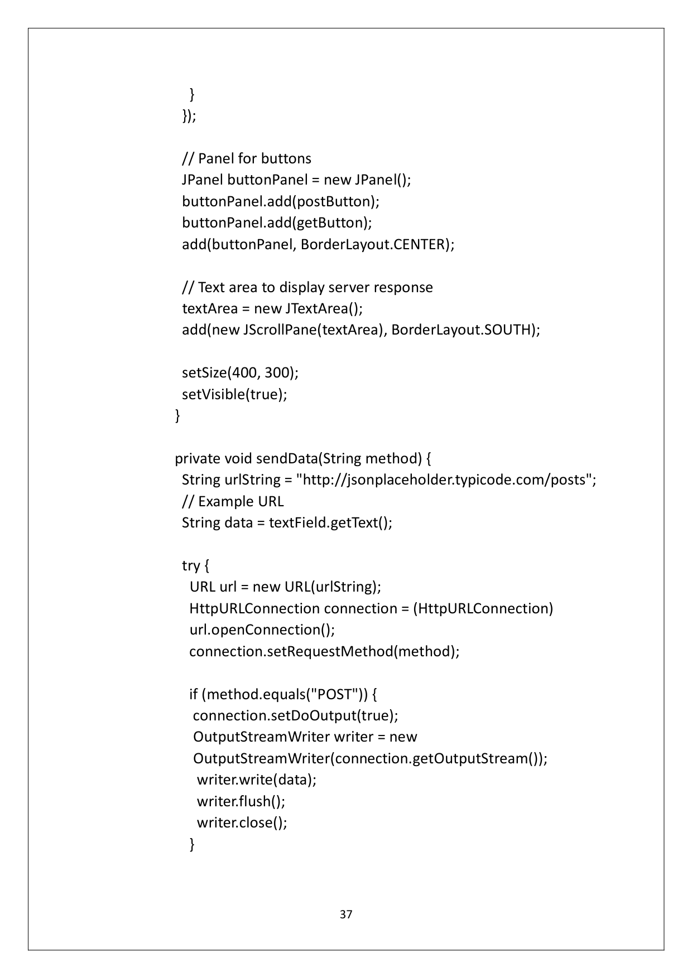

Page 41

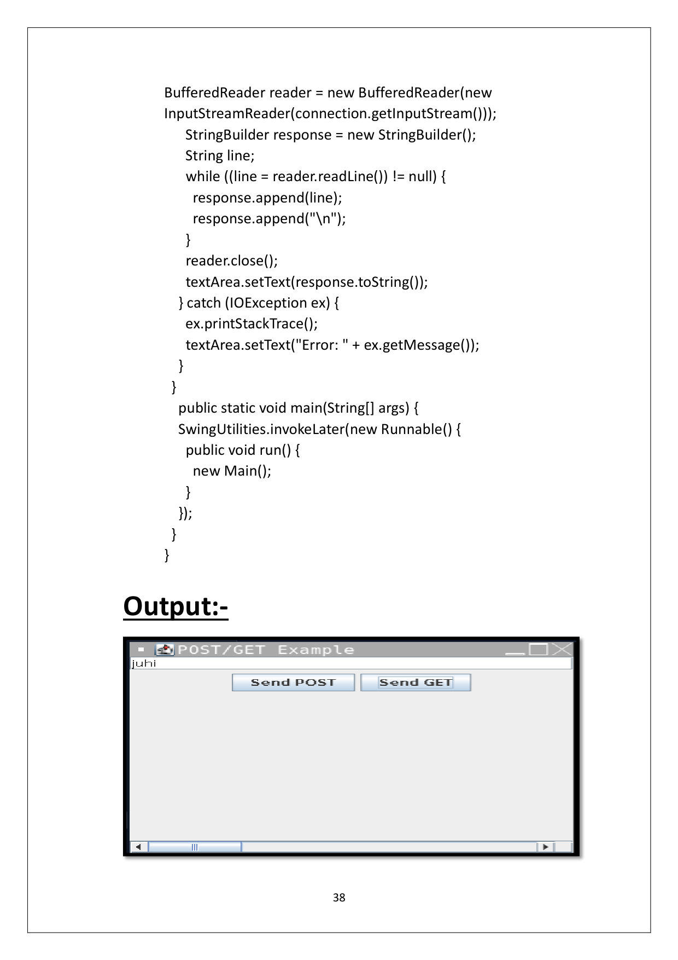

Page 42

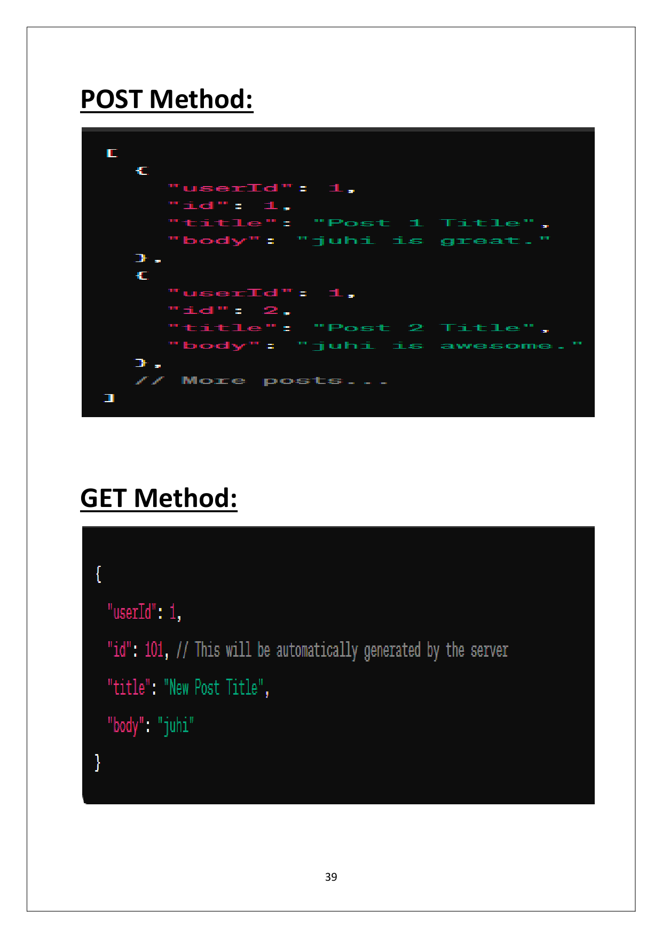

Page 43

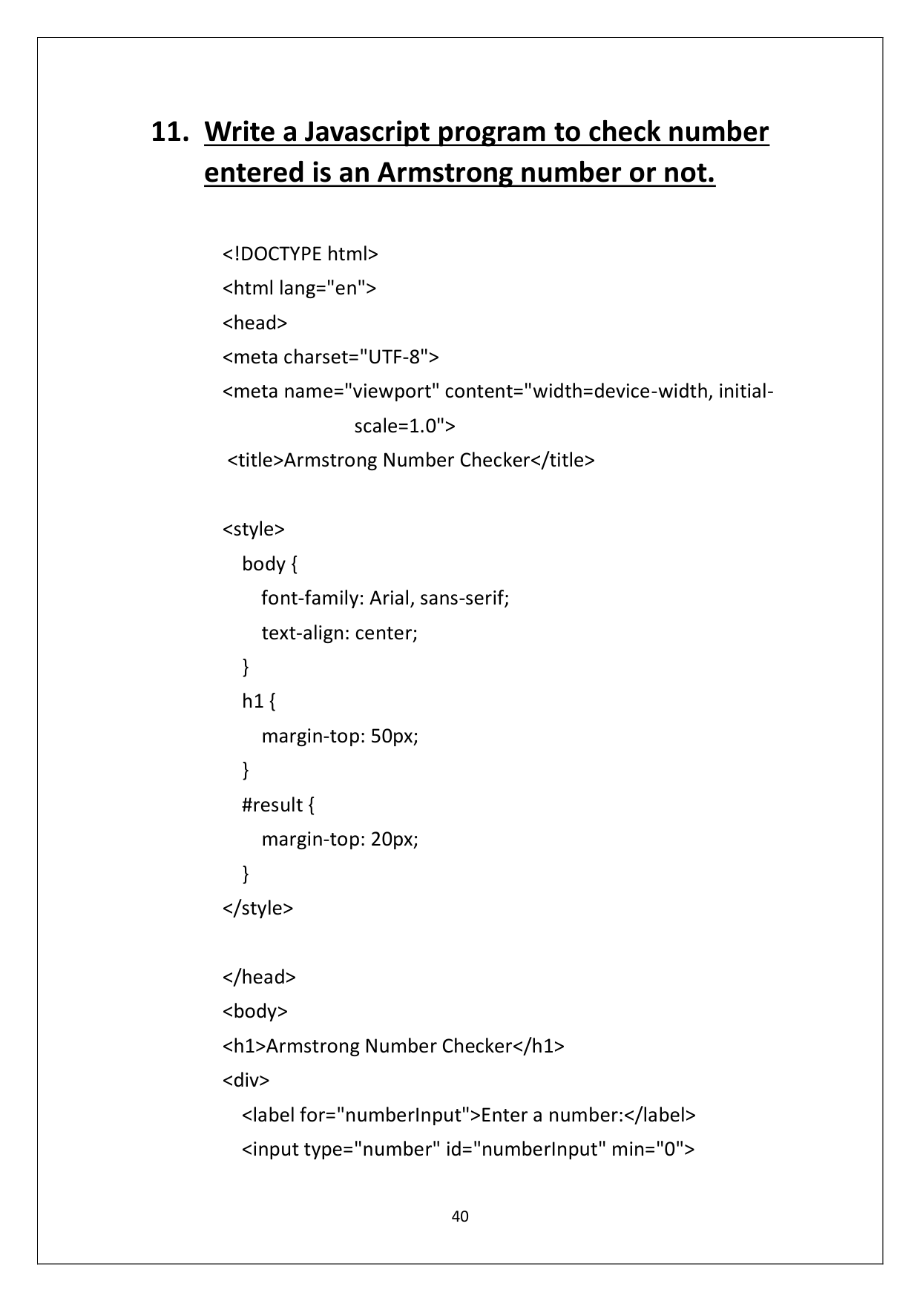

Page 44

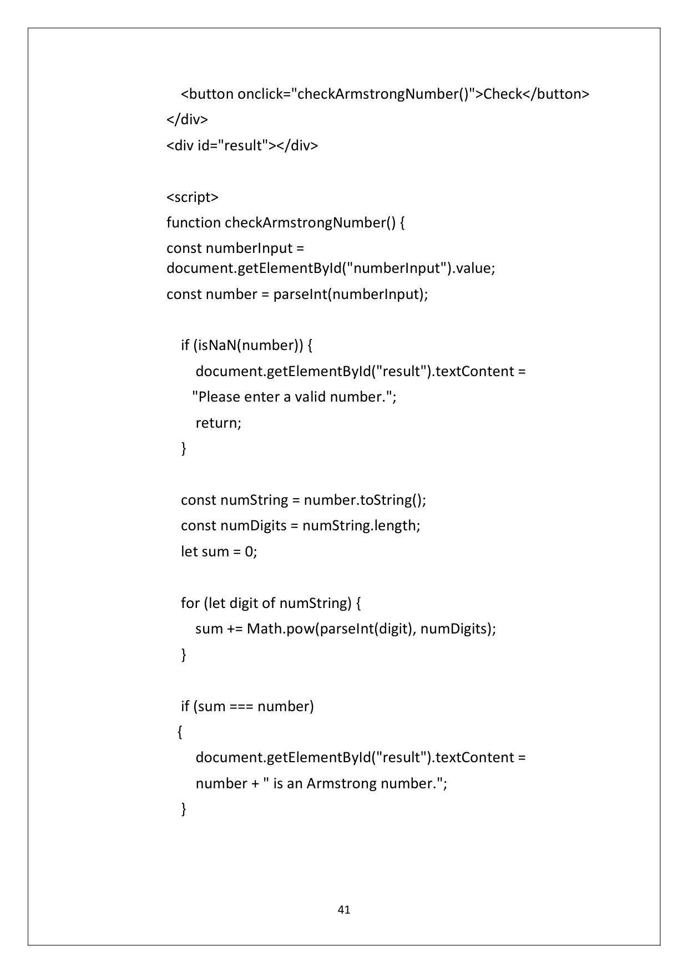

Page 45

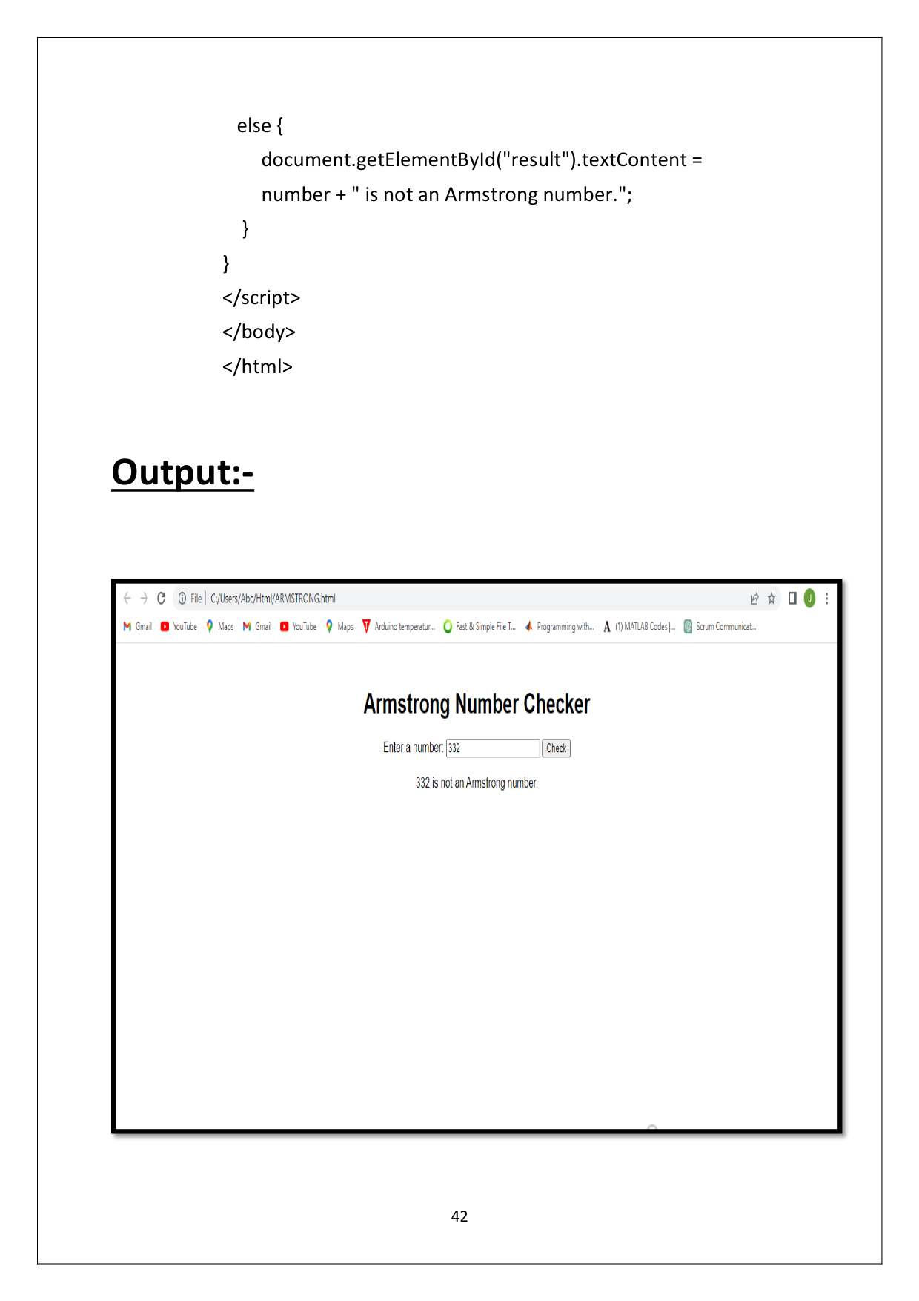

Page 46

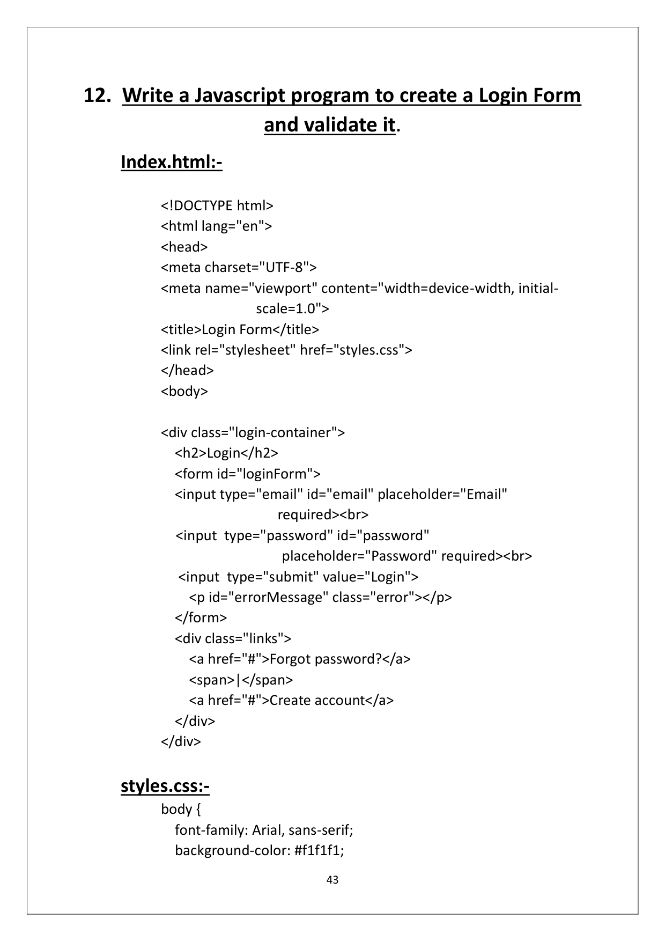

Page 47

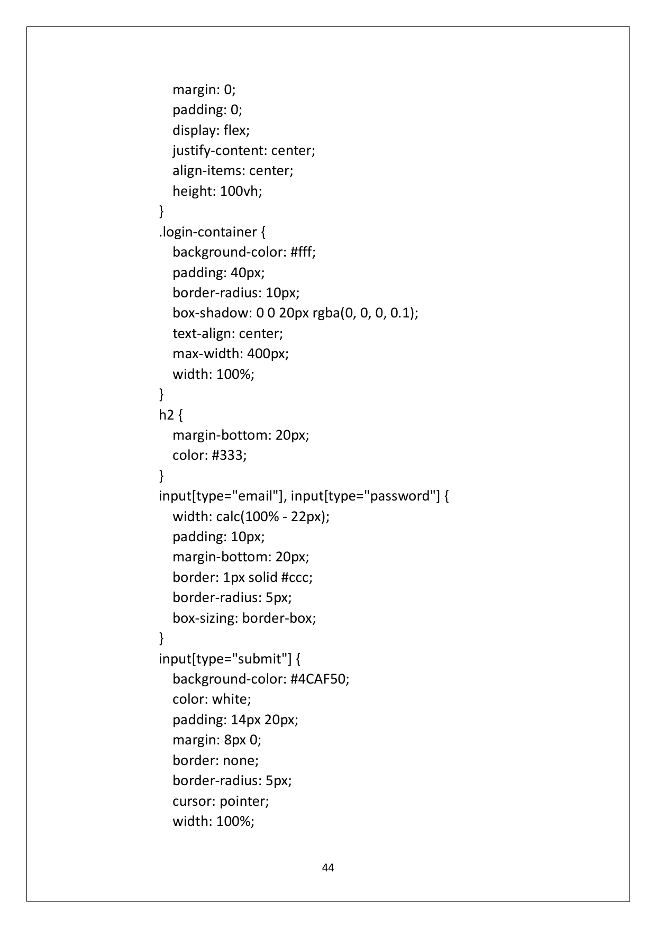

Page 48

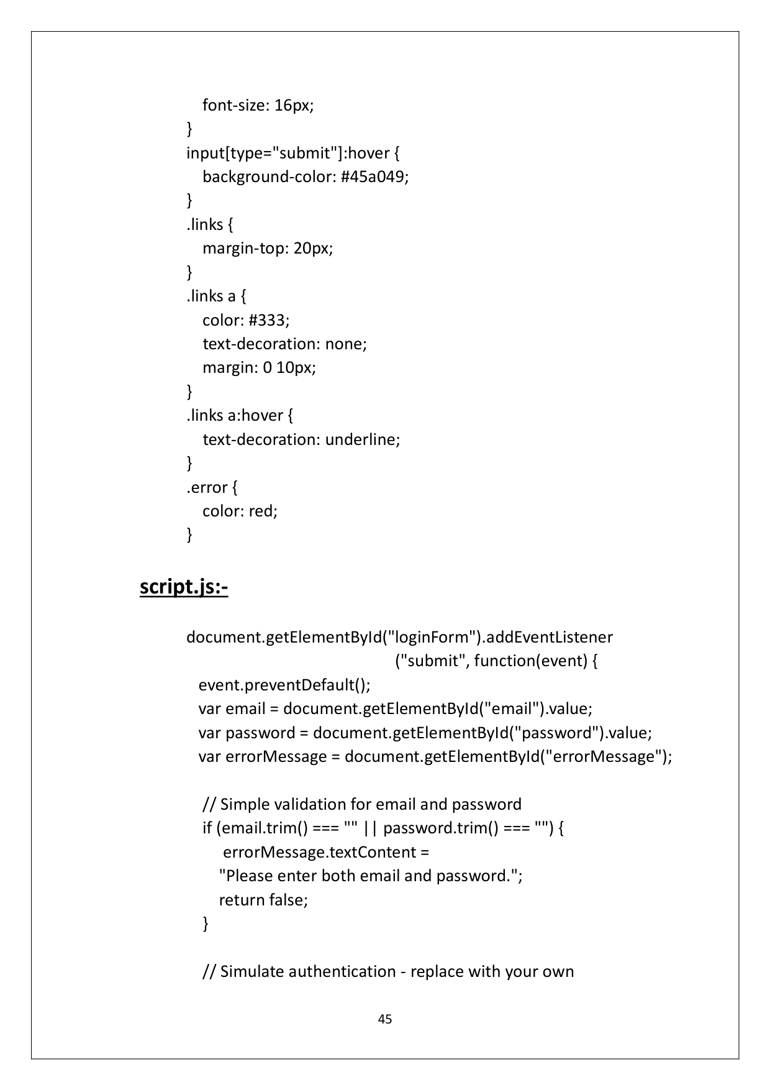

Page 49

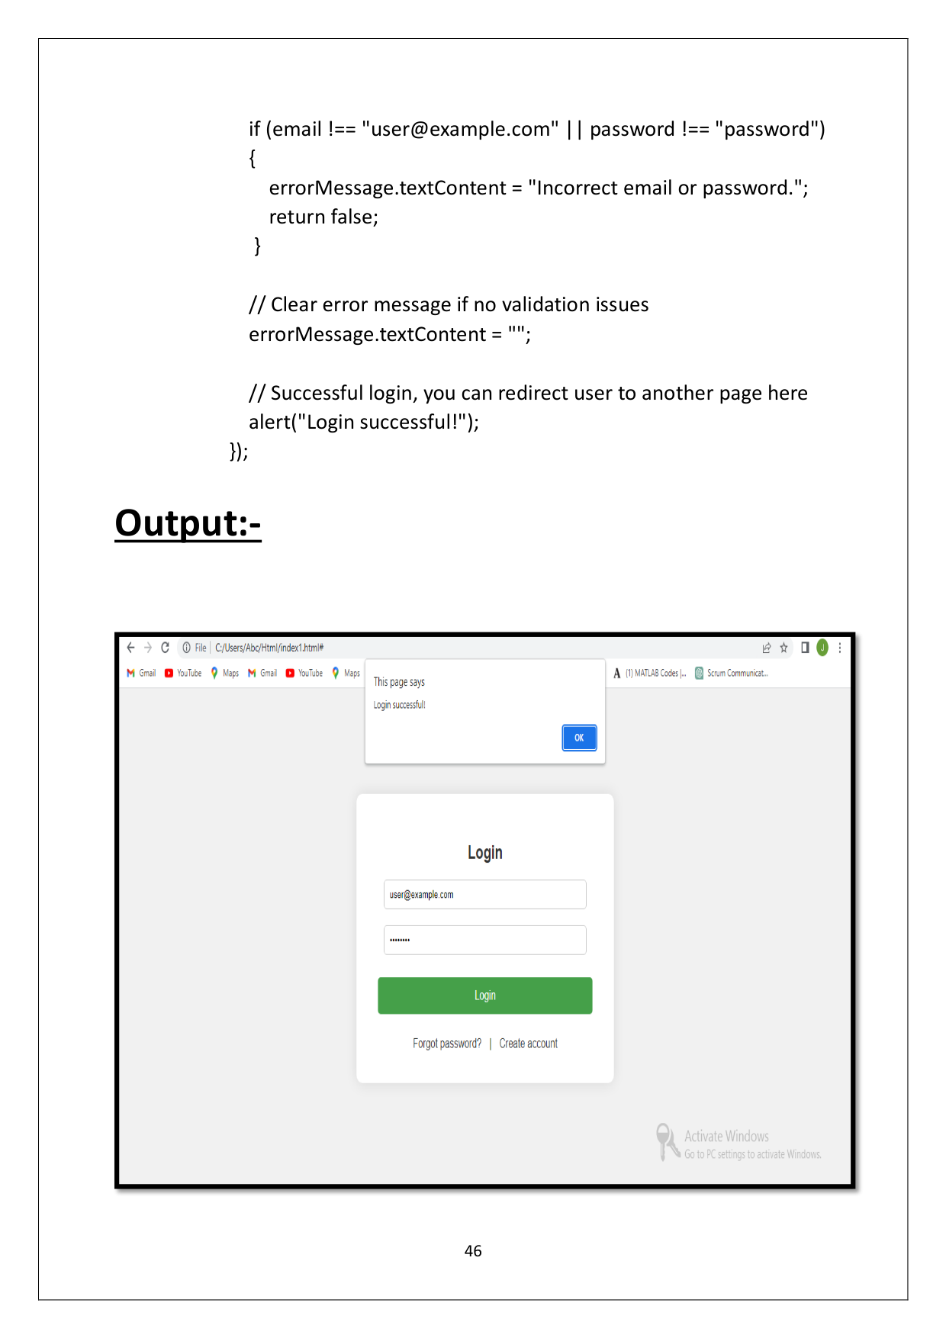

Page 50

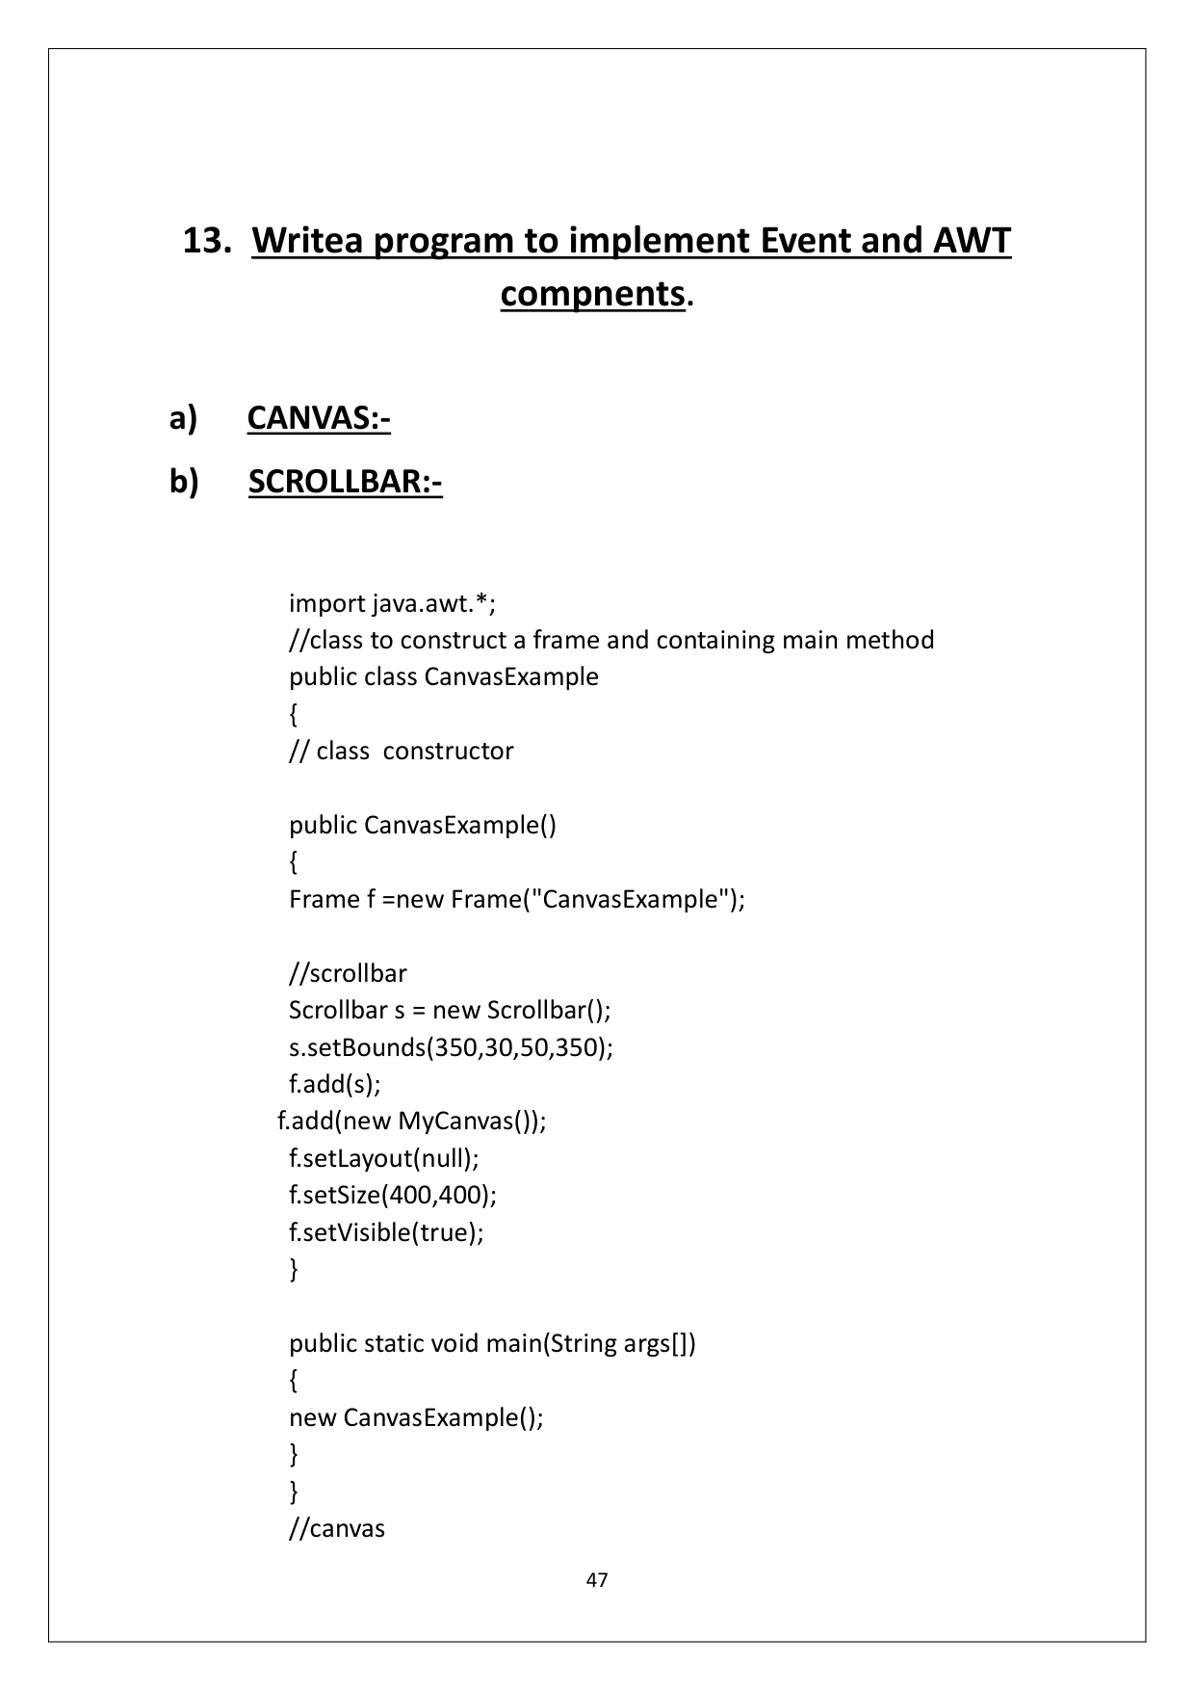

Page 51

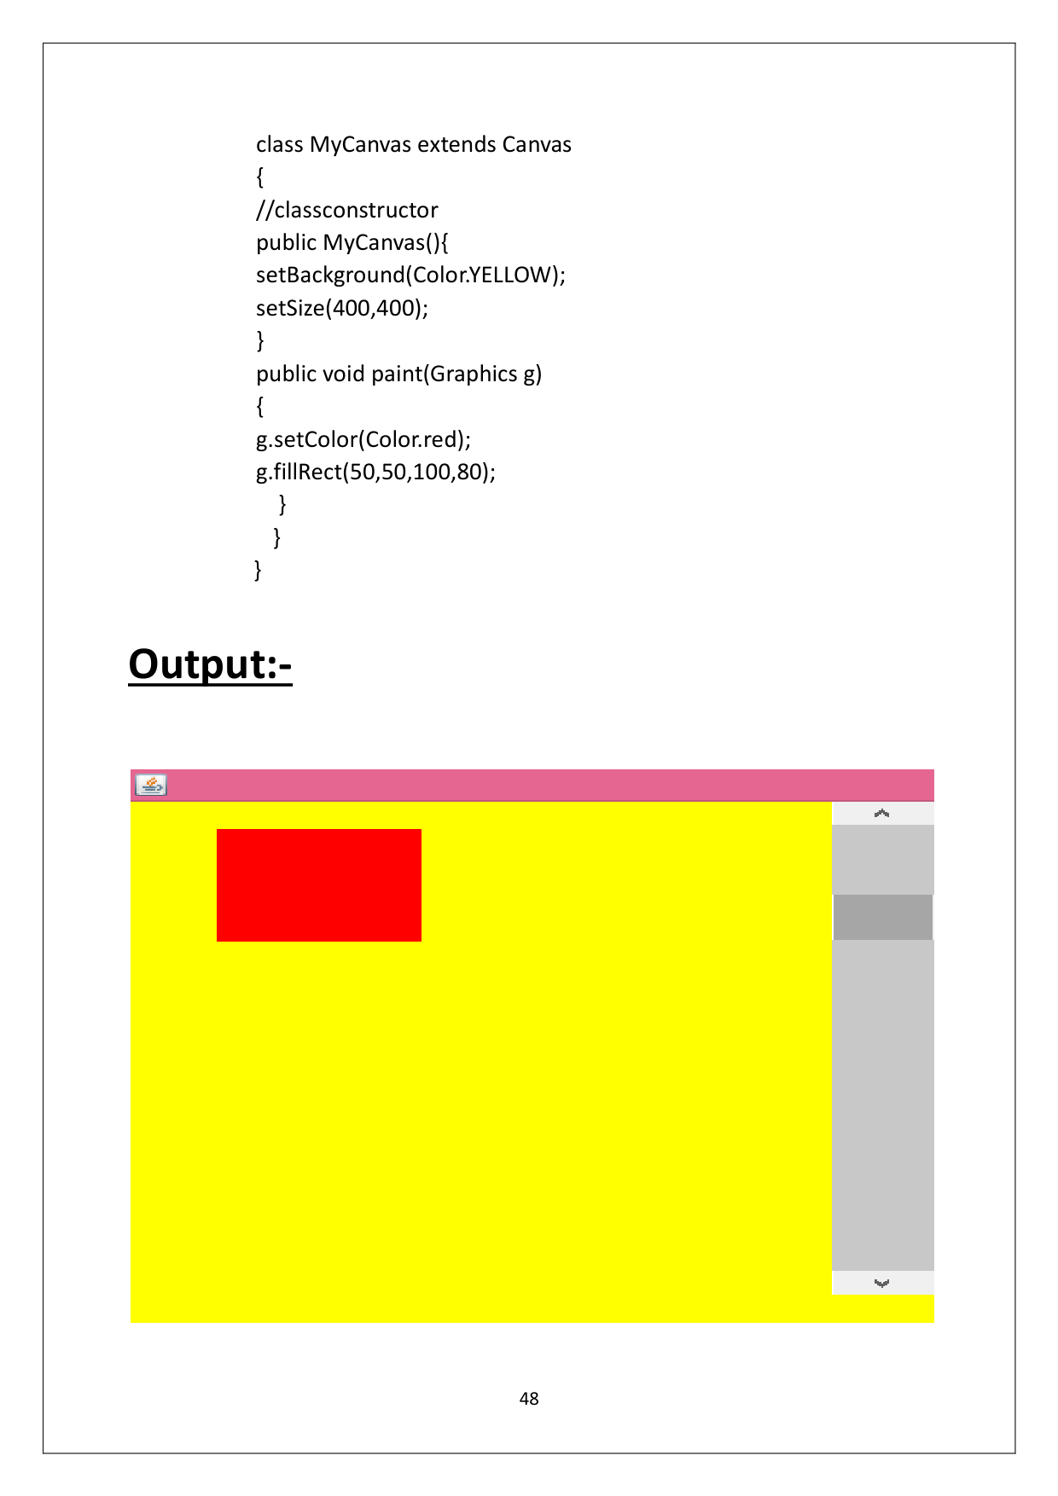

Page 52

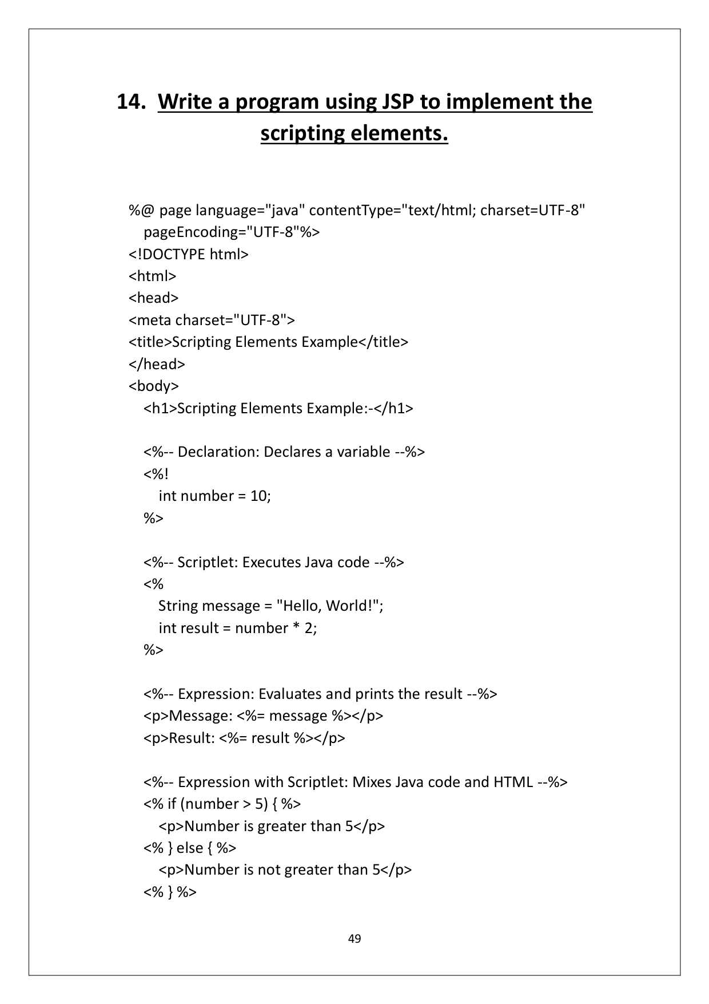

Page 53

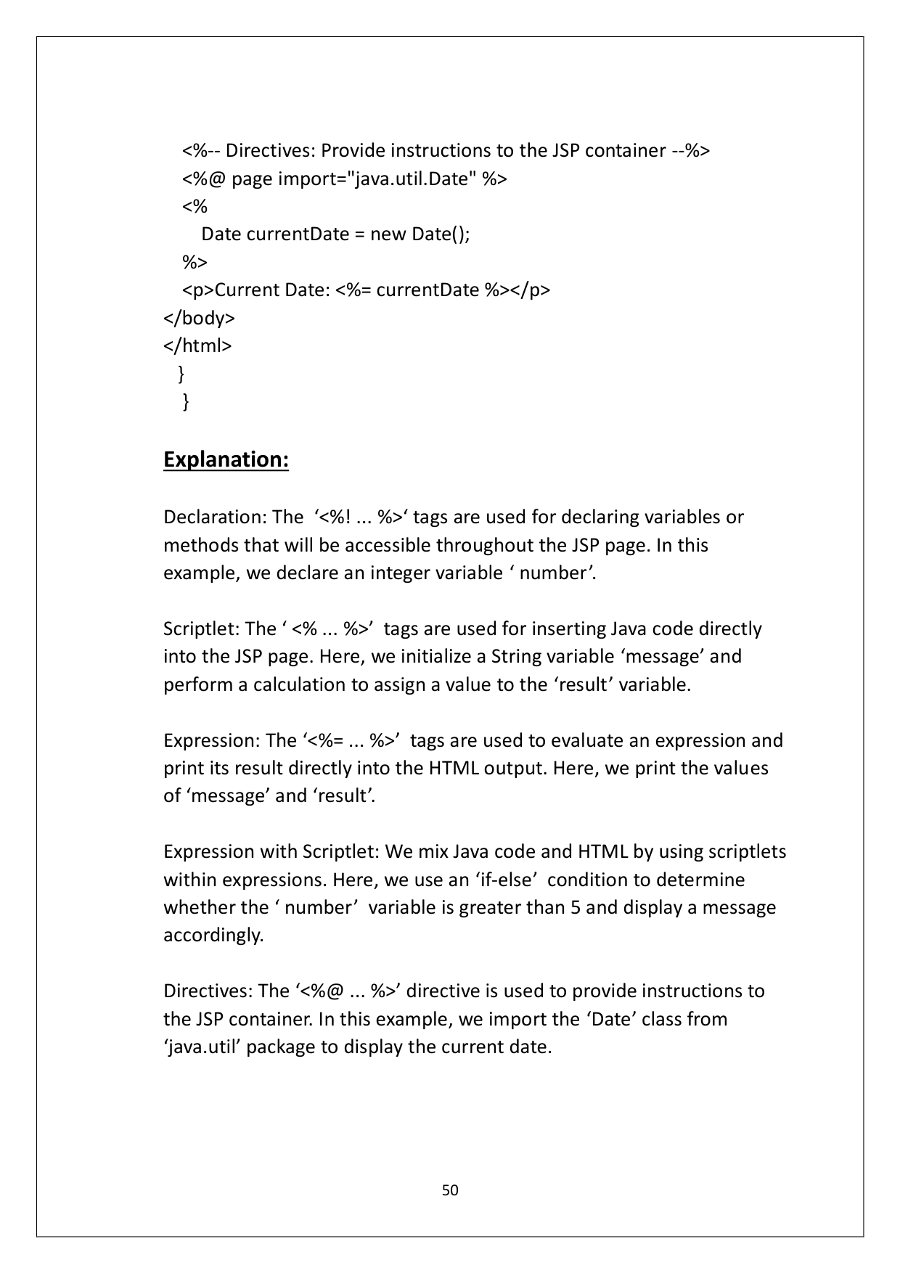

Page 54

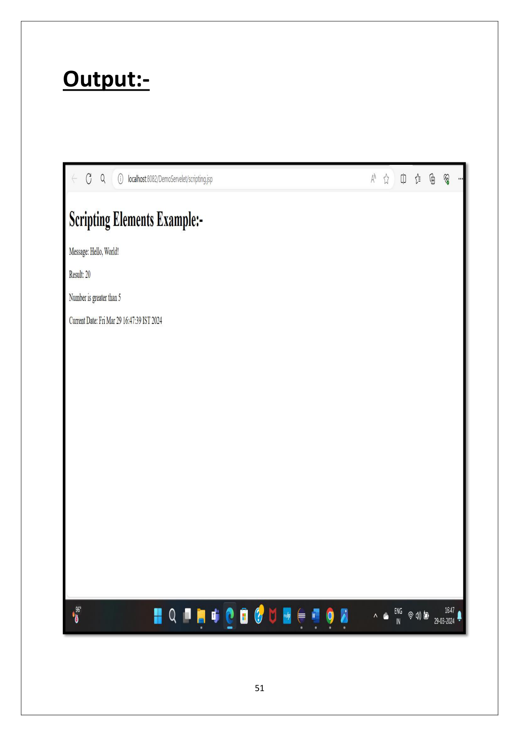

Page 55

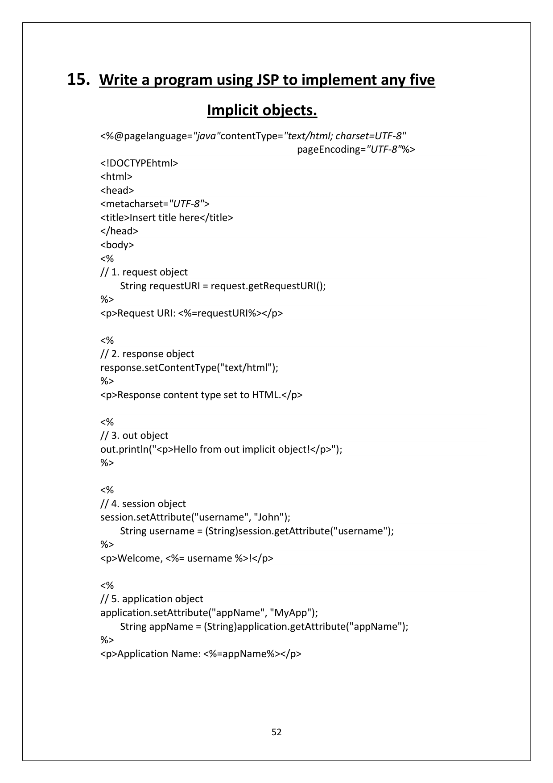

Page 56

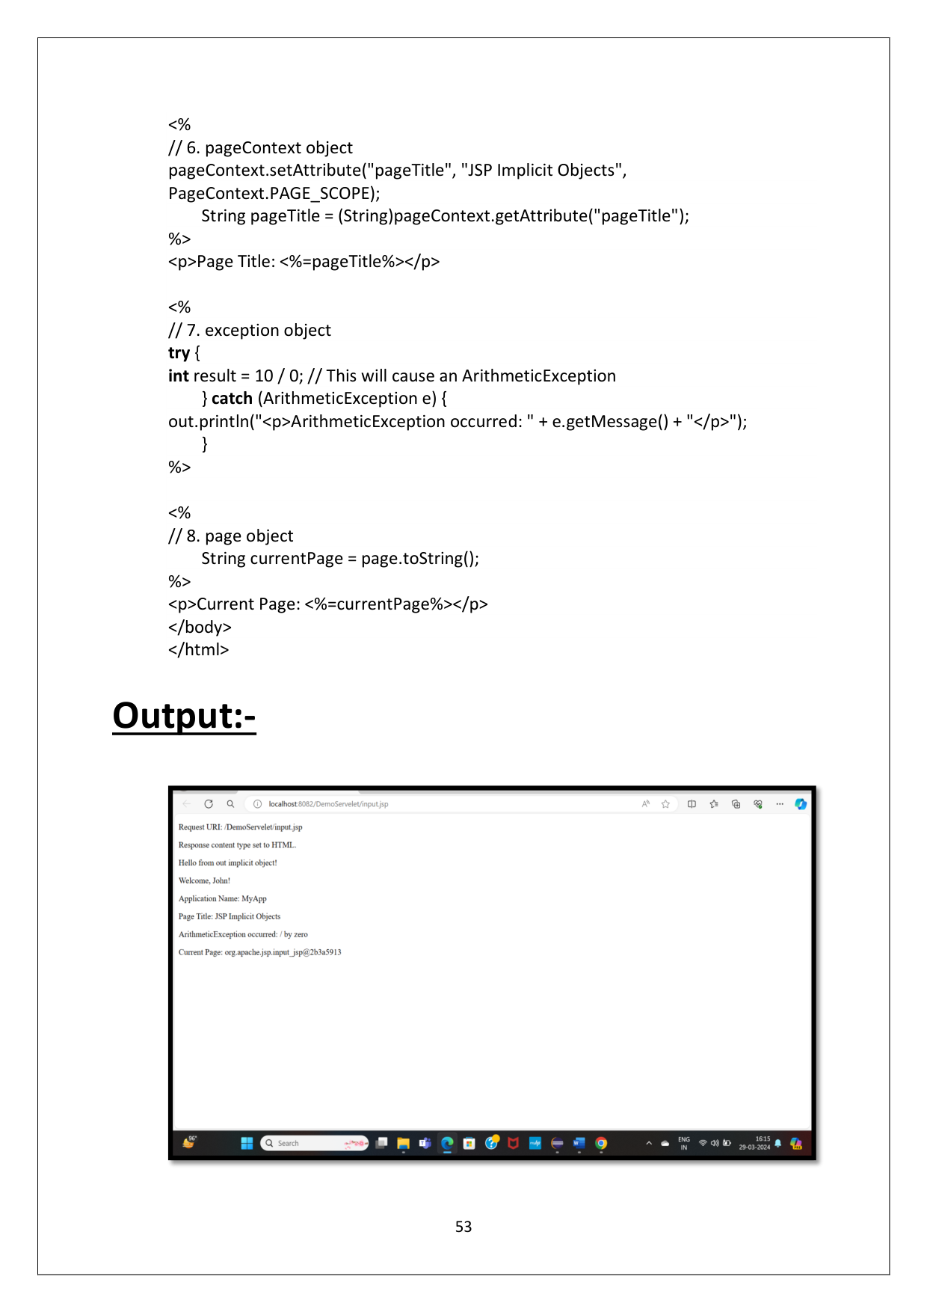

Page 57

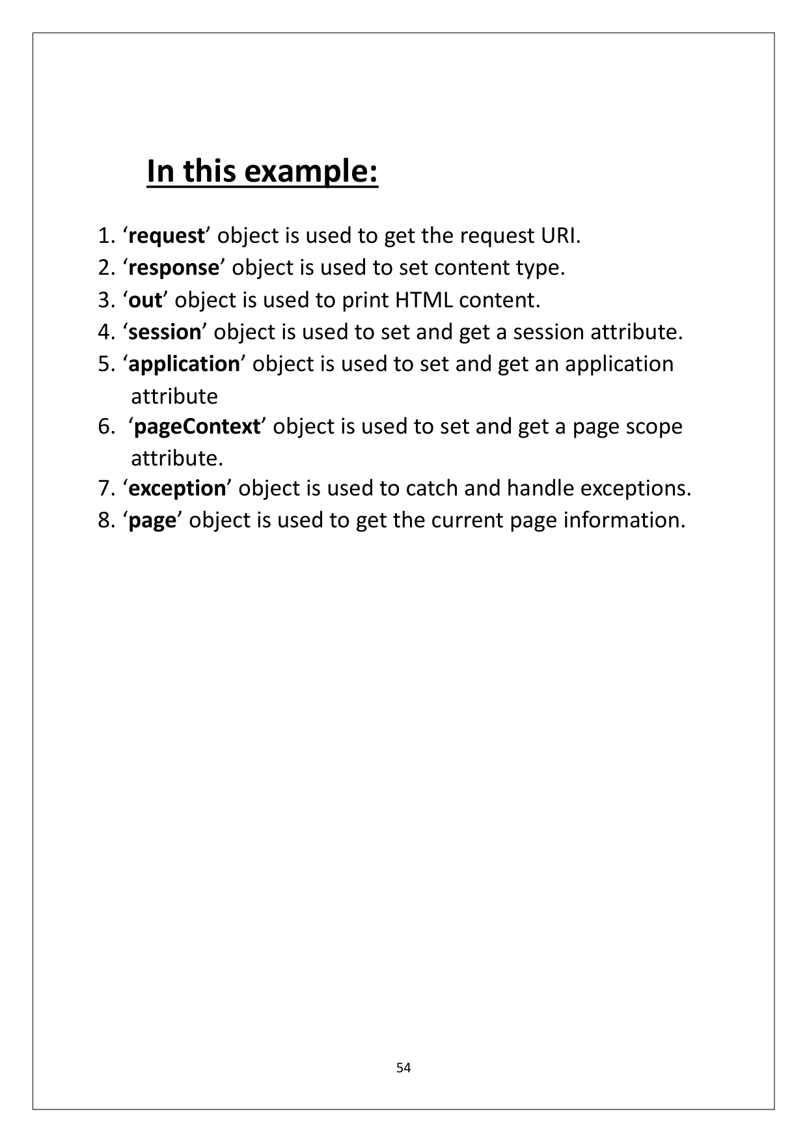

MAHARSHI DAYANAND UNIVERSITY,   
ROHTAK   
   
   
   
   
   
   
   
   
   
   
   
   
   
   
Department of Computer Science & Applications   
   
   
 Practical Assignment -1   
   
 (Session 2023 -24)   
   
BASED O N   
 SOFTWARE LAB – 3 : 20MCA22C1   
   
Submitted By: Submitted To:   
Juhi Dr.Gopal Singh   
MCA - 1st year (Associate Professor)   
Roll No. : 23170

INDEX   
Sr. No. PROGRAM S PAGE NO. REMARKS   
1. Write a program in Java to implement   
print to develop a window using an Applet . 1,2   
2. Write a program to generate Form using   
HTML & JAVASCRIPT. 3 to 7   
3. Write a program to implement Event and   
AWT components .   
 a) Button   
 b) Checkbox 8 to 12   
 4. Write a program to implement Swing   
components .   
 a) Button   
 b) Table   
 c) Tree   
 d) Checkbox Pane 13 to 19   
5. Write a program to implement Swing   
components .   
 a) Tabbed Pane   
 b) Scroll Pan e 20 to 23   
6. Write a program in Java to implemen t all   
the phases of life cycle of Servlet . 24,25   
7. Write a program in Java to show   
implement DHTML and CSS with   
javascript . 26 to 28   
8. How is role of server side is different from   
client side in a typical website? Clear using   
an example. 29 to 33

9. Write a p rogram in Java t o using JSP   
which accep t two integer numbers from   
user and display the result. 34,35   
 10. Write a program in Jav a using POST and   
GET method in S wing . 36 to 39   
 11. Write a Javascript Program to check   
number entered is an Armstrong number   
or not. 40 to 42   
12. Write a Javascript program to create a   
Login Form and validate it. 43 to 46   
13.   
Write a program to implement Event and   
AWT components .   
 a) CANVAS   
 b) SCROLLBAR 47,48   
14. Write a program using JSP to implement   
the Scripting Elements . 49 to 51   
15. Write a program using JSP to implement   
any five Implicit O bjects. 52 to 54

1   
 1. Write a p rogram to develop a window using   
an Applet.   
   
 RectangleWindow Applet.java: -   
.   
 import java.applet.Applet;   
 import java.awt.*;   
 public class RectangleWindow extends Applet {   
 public void paint(Graphics g) {   
   
 // Set font style and font name   
 Font font = new Font("Arial", Font.BOLD |   
 Font.ITALIC, 18);   
 g.setFont(font);   
   
 // Draw rectangle   
 g.setColor(Color.BLUE);   
 g.fill Rect(50, 50, 300, 200);   
   
 // Set font color   
 g.setColor(Color.WHITE);   
   
 // Draw text   
 String text = "This is a rectangle window";   
 FontMetrics fm = g.getFontMetrics();   
 int textWidth = fm.stringWidth(text);   
 int x = (getWidth() - textWidth) / 2;   
 // Center the text horizontally   
 int y = getHeight() / 2;   
 // Center the text vertically   
 g.drawString(text, x, y);   
 }   
 }

2   
 RectangleWindow Applet.html: -   
   
<!DOCTYPE html>   
<html>   
<head>   
<title>Rectangle Window Applet</title>   
</head>   
<body>   
 <h1>Rectangle Window Applet Example</h1>   
 <hr>   
 <applet code="RectangleWindow.class" width="400"   
 height="300">   
 </applet>   
</body>   
</html>   
   
Output: -

3   
   
2. Write a program to generate Form using HTML &   
JAVA SCRIPT.   
   
 Form .html: -   
   
<!DOCTYPE html>   
<html lang="en">   
<head>   
<meta charset="UTF -8">   
<meta name="viewport" content="width=device -width, initial -   
 scale=1.0">   
<title>College Student Details Form</title>   
<style>   
   
 body {   
 font-family: Arial, sans -serif;   
 background:linear -gradient(45deg,dodgerblue,white,purple);   
 margin: 0;   
 padding: 20px;   
 box-sizing: border -box;   
 }   
 .form -container {   
 background -color: #fff;   
 padding: 30px;   
 border -radius: 10px;   
 box-shadow: 0 0 10px rgba(0, 0, 0, 0.1);   
 max -width: 500px;   
 margin: auto;   
 }   
 h2 {   
 color: #007bff;   
 text-align: center;   
 margin -bottom: 30px;   
 }   
 .form -group {

4   
 margin -bottom: 20px;   
 }   
 .form -group label {   
 font-weight: bold;   
 display: block;   
 margin -bottom: 5px;   
 color: #555;   
 }   
 .form -group input[type="text"], .form -group select {   
 width: calc(100% - 22px);   
 padding: 8px;   
 border: 1px solid #ccc;   
 border -radius: 5px;   
 transition: border -color 0.3s;   
 box-sizing: border -box;   
 font-size: 16px;   
 }   
 .form -group input[type="text"]:focus, .form -group select:focus {   
 border -color: #007bff;   
 outline: none;   
 }   
 .form -group button {   
 background -color: #007bff;   
 color: #fff;   
 border: none;   
 padding: 10px 20px;   
 border -radius: 5px;   
 cursor: pointer;   
 transition: background -color 0.3s;   
 margin -right: 10px;   
 font-size: 16px;   
 }   
 .form -group button[type="reset"] {   
 background -color: #dc3545;   
 }   
 .form -group button:hover {   
 background -color: #0056b3;

5   
 }   
 #address{   
 width:12.7cm;   
 font-size: 14px;   
 }   
 @media screen and (max -width: 600px) {   
 .form -group input[type="text"], .form -group select {   
 width: 100%;   
 }   
 }   
</style>   
</head>   
<body>   
   
<div class="form -container">   
 <h2>College Student Details Form</h2>   
 <div class="form -group">   
 <label for="name">Name:</label>   
 <input type="text" id="name" placeholder="Enter your name">   
 </div>   
 <div class="form -group">   
 <label for="age">Age:</label>   
 <input type="text" id="age" placeholder="Enter your age">   
 </div>   
 <div class="f orm-group">   
 <label for="gender">Gender:</label>   
 <select id="gender">   
 <option value="male">Select</option>   
 <option value="male">Male</option>   
 <option value="female">Female</option>   
 <option value="other">Other</option>   
 </select>   
 </div>   
 <div class="form -group">   
 <label for="department">Department:</label>   
 <input type="text" id="department" placeholder="Enter your   
 department">

6   
 </div>   
 <div class="form -group">   
 <label for=" year">Year:</label>   
 <input type="text" id="year" placeholder="Enter your year of   
 study">   
 </div>   
 <div class="form -group">   
 <label for="address">Address:</label>   
 <textarea id="address" placeholder="Enter your   
 address"></textarea>   
 </div>   
 <div class="form -group">   
 <button type="button onclick="submitForm()">Submit</button>   
 <button type="reset" onclick="reset()">Reset </button>   
 </div>   
</div>   
</body>   
</html>   
   
 Form.js :-   
   
<script>   
 function submitForm() {   
 var name = document.getElementById('name').value;   
 var age = document.getElementById('age').value;   
 var gender = document.getElementById('gender').value;   
 var department= document.getElementById('department') .   
 value;   
 var year = document.getElementById('year').value;   
 var address = document.getElementById('address').value;   
 alert('Student details submitted: \nName: ' + name + ' \nAge: ' +   
 age + ' \nGender: ' + gender + ' \nDepartment: ' +   
 department + ' \nYear: ' + year + ' \nAddress: ' + address);   
 }   
   
 function reset(){   
 document.getElementById('name').value=" ";

7   
 document.getElementById('age').value=" ";   
 document.getElementById('gender').value=" ";   
 document.getElementById('department').value=" ";   
 document.getElementById('year').value=" ";   
 document.getElementById('address').value=" ";   
 }   
</script>   
   
   
   
Output: -

8   
   
3. Write a progr am to implement Event and AWT   
components .   
 a) Button: -   
   
import java.awt.*;   
import java.awt.event.*;   
   
public class ButtonExample extends Frame implements ActionListener {   
 private Button button;   
   
 public ButtonExample() {   
 // Create a frame   
 super("Button Example");   
   
 // Create a button   
 button = new Button("Click Me");   
   
 // Set the layout   
 setLayout(new FlowLayout());   
   
 // Add button to the frame   
 add(button);   
   
 // Register action liste ner for the button   
 button.addActionListener(this);   
   
 // Set frame properties   
 setSize(300, 200);   
 setVisible(true);   
   
 // Handle window closing event   
 addWindowListener(new WindowAdapter() {   
 public void windowClosing(WindowEvent e) {

9   
 dispose(); // Release resources   
 }   
 });   
 }   
   
 // Action listener implementation   
 public void actionPerformed(ActionEvent e) {   
 if (e.getSource() == butt on) {   
 // Display some text in a dialog box   
 Dialog dialog = new Dialog(this, "Button Clicked", true);   
 dialog.setLayout(new FlowLayout());   
 Label label = new Label("Button Clicked!");   
 dialog.add(labe l);   
 dialog.setSize(200, 100);   
 dialog.setVisible(true);   
 }   
 }   
 public static void main(String[] args) {   
 new ButtonExample(); // Create an instance of ButtonExample   
 }   
}   
   
Output :-

10   
   
 After Button Clicked :-   
   
   
   
 b) Checkbox :-   
import java.awt.*;   
import java.awt.event.*;   
   
public class CheckboxExample extends Frame implements ItemListener {   
 private Checkbox checkbox;   
   
 public CheckboxExample() {   
 // Create a frame   
 super("Checkbox Example");   
   
 // Create a checkbox   
 checkbox = new Checkbox("Check Me");   
   
 // Set the layout

11   
 setLayout(new FlowLayout());   
   
 // Add checkbox to the frame   
 add(checkbox);   
   
   
   
   
 // Register item listener for the checkbox   
 checkbox.addItemListener(this);   
   
 // Set frame properties   
 setSize(300, 200);   
 setVisible(true);   
   
 // Handle window closing event   
 addWindowListener(new WindowAdapter() {   
 public void windowClosing(WindowEvent e) {   
 dispose(); // Release resources   
 }   
 });   
 }   
   
 // Item listener implementation   
 public void itemStateChanged(ItemEvent e) {   
 if (e.getSource() == checkbox) {   
 if (checkbox.getState()) {   
 // Display message in a dialog box   
 Dialog dialog = new Dialog(this, "Checkbox Event", true);   
 dialog.setLayout(new FlowLayout());   
 Label label = new Label("Checkbox clicked!");   
 dialog.add(label);   
 dialog.setSize(200, 100);   
 dialog.setVisible(true);   
 }   
 }

12   
   
Output :-

13   
 4. . Write a progr am to implement swing   
components .   
   
 a) Button: -   
import javax.swing.*;   
import java.awt.event.*;   
   
public class ButtonExample {   
 public static void main(String[] args) {   
 // Create a JFrame   
 JFrame frame = new JFrame("Button Example");   
   
 // Create a JButton   
 JButton button = new JButton("Click Me");   
   
 // Add action listener to the button   
 button.addActionListener(new ActionList ener() {   
 public void actionPerformed(ActionEvent e) {   
 JOptionPane.showMessageDialog(null, "Button Clicked!");   
 // Display a message dialog   
 }   
 });   
   
 // Set layout for the frame   
 frame.setLayout(new java.awt.FlowLayout());   
   
 // Add button to the frame   
 frame.add(button);   
   
 // Set frame properties   
 frame.setSize(300, 200);   
 frame .setDefaultCloseOperation(JFrame.EXIT_ON_CLOSE);   
 frame.setVisible(true);   
 }   
 }   
 }

14   
 Output :-   
   
   
   
   
   
   
   
 b) Table: -   
   
import javax.swing.*;   
import javax.swing.table.DefaultTableModel;   
   
public class TableExample {   
 public static void main(String[] args) {   
 // Create a JFrame   
 JFrame frame = new JFrame("Table Example");

15   
   
 // Create a table model   
 DefaultTableModel model = new DefaultTableModel();   
   
 // Add columns to the model   
 model.addColumn("ID");   
 model.addColumn("Name");   
 model.addColumn("Age");   
   
 // Add rows to the model   
 model.addRow(new Object[]{"1", "John Doe", "30"});   
 model.addRow(new Object[]{"2", "Jane Smith", "25"});   
 model.addRow(new Object[]{"3", "Tom Brown", "35"});   
   
 // Create a JTable with the model   
 JTable table = new JTable(model);   
   
 // Create a JScrollPane to hold the table   
 JScrollPane scrollPane = new JScrollPane(table);   
   
 // Add scroll pane to the frame   
 frame.add(scrollPane);   
   
 // Set frame properties   
 frame.setSize(400, 300);   
 frame.setDefaultCloseOperation(JFrame.EXIT_ON_CLOSE);   
 frame.setVisible(true);   
 }   
}

16   
 Output :-   
   
   
   
   
 c) Tree:-   
   
import javax.swing.*;   
import javax.swing.tree.DefaultMutableTreeNode;   
public class TreeExample {   
 public static void main(String[] args) {   
 // Create a JFrame   
 JFrame frame = new JFrame("Tree Example");   
 // Create tree nodes   
 DefaultMutableTreeNode rootNode = new   
 DefaultMutableTreeNode("Root")   
 DefaultMutableTreeNode node1 = new   
 DefaultMutableTreeNode("Node 1");   
 DefaultMutableTreeNode node2 = new   
 DefaultMutableTreeNode("Node 2");   
 DefaultMutableTreeNode node3 = new   
 DefaultMutableTreeNode("Node 3");

17   
   
 // Add child nodes to the root node   
 rootNode.add(node1);   
 rootNode.add(node2);   
 rootNode.add(node3);   
   
 // Create a JTree with the root node   
 JTree tree = new JTree(rootNode);   
 // Create a JScrollPane to hold the tree   
 JScrollPane scrollPane = new JScrollPane(tree);   
 // Add scroll pane to the frame   
 frame.add(scrol lPane);   
 // Set frame properties   
 frame.setSize(400, 300);   
 frame.setDefaultCloseOperation(JFrame.EXIT_ON_CLOSE);   
 frame.setVisible(true);   
 }   
 }   
   
Output :-

18   
   
   
 d) CheckedPane :-   
   
import java.awt.Color;   
import java.awt.Dimension;   
import java.awt.GridBagConstraints;   
import java.awt.GridBagLayout;   
import java.util.ArrayList;   
import javax.swing.JCheckBox;   
import javax.swing.JFrame;   
import javax.swing.JPanel;   
import javax.swing.JScrollP ane;   
import javax.swing.JSplitPane;   
public class CheckboxPane extends JFrame {   
private ArrayList<JCheckBox> boxes = new ArrayList<JCheckBox>();   
 JSplitPanesplitPane;   
 private JPanelleftPanel;   
 private JPanelrightPanel;   
 public CheckboxPane() {   
 leftPanel = new JPanel(new GridBagLayout());   
 rightPanel = new JPanel(new GridBagLayout()) {   
 @Override   
 public Dimension getPreferredSize() {   
 return new Dimension(200, 200);   
 }   
 };   
   
splitPane = new JSplitPane(JSplitPane.HORIZO NTAL_SPLIT, leftPanel, new   
JScrollPane(rightPanel));   
leftPanel.setBackground(Color.BLUE);   
 add(splitPane);   
addBoxes();   
 }

19   
 void addBoxes() {   
 int i = 0;   
 GridBagConstraintsgbc = new GridBagConstraints();   
 gbc.gridwidth = GridBagConstraints.REMAINDER;   
 for (i = 0; i< 10; i++) {   
leftPanel.add(new JCheckBox("Checkbox " + i), gbc);   
 }   
 }   
 public static void main(String[] args) {   
CheckboxPanecb = new CheckboxPane();   
cb.setDefaultCloseOperation(JFrame.DISPOSE_ON_CLOSE);   
cb.pack();   
cb.setLocationRelativeTo(null);   
cb.setVisible(true);   
 }   
}   
   
   
Output :-

20   
 5. Write a program to implement Swing   
 Components .   
   
 a) TabbedPane :-   
   
import javax.swing.*;   
public class TabbedPaneExample {   
 public static void main(String[] args) {   
 // Create a JFrame   
 JFrame frame = new JFrame("Tabbed Pane Example");   
   
 // Create a JTabbedPane   
 JTabbedPane tabbedPane = new JTabbedPane();   
   
 // Create tabs   
 JPanel ta b1 = new JPanel();   
 JLabel label1 = new JLabel("Content of Tab 1");   
 tab1.add(label1);   
   
 JPanel tab2 = new JPanel();   
 JLabel label2 = new JLabel("Content of Tab 2");   
 tab2.add(label2);   
   
 JPanel tab3 = new JPanel();   
 JLabel label3 = new JLabel("Content of Tab 3");   
 tab3.add(label3);   
   
 // Add tabs to the tabbed pane   
 tabbedPane.addTab("Tab 1", tab1);   
 tabbedPane.addTab("Tab 2", tab2);   
 tabbedPane.addTab("Tab 3", tab3);   
   
 // Add tabbed pane to the frame   
 frame.add(tabbedPane);

21   
   
 // Set frame properties   
 frame.setSize(400, 300);   
 frame.setDefaultCloseOperation(JFrame.EXIT_ON_CLOSE);   
 frame.setVisible(true);   
 }   
}   
 public static boolean matchSubstring(String mainString, String   
 substring) {   
   
 int mainLength = mainString.length();   
 int subLength = substring.length();   
   
 // Iterate through the main string   
 for (int i = 0; i <= mainLength - subLength; i++) {   
 int j;   
 /*Check if the substring matches the current portion of the main   
 string*/   
   
 for (j = 0; j < subLength; j++) {   
 if (mainString.charAt(i + j) != substring.charAt(j)) {   
 break;   
 }   
 }   
 /* If the inner loop completed, it means the substring matches */   
 if (j == subLength) {   
 return true;   
 }   
 }   
   
 // If no match is found, return false   
 return false;   
 }   
 public static void main(String[] args) {   
 String mainString = "Hello World";   
 String substring = "World";

22   
 // Check if the substring matches the main string   
 if (matchSubstring(mainString, substring))   
 {   
 System.out.println("Main String is: "+mainS tring);   
 System.out.println("Sustring is : "+substring);   
 System.out.println("Substring found in Main String!!!");   
 }   
 else   
 {   
 System.out.println("Main String is "+ mainString);   
 System.out.println("Sustring is :"+ substring);   
 System.out.println("Substring not found in Main String!!!");   
   
 }   
 }   
}   
   
Output :-   
   
   
   
 b) ScrollPane :-   
 import javax.swing.*;

23   
 public class ScrollPaneExample {   
public static void main(String[] args) {   
 // Create a JFrame   
 JFrame frame = new JFrame("ScrollPane Example");   
 // Create a JTextArea with a long text   
 JTextArea textArea = new JTextArea(20, 40);   
 for (int i = 0; i < 1 00; i++) {   
 textArea.append("This is line " + (i + 1) + " \n");   
 }   
   
 // Create a JScrollPane with the text area   
 JScrollPane scrollPane = new JScrollPane(textArea);   
   
 // Add scroll pane to the frame   
 frame.add(scrollPane);   
 // Set frame properties   
 frame.setSize(400, 300);   
 frame.setDefaultCloseOperation(JFrame.EXIT_ON_CLOSE);   
 frame.setVisible(true);   
 }   
}   
   
Output: -

24   
 6. Write a program in Java to implement all the phases of   
the life cycle of servelet .   
   
   
Servlet Life Cycle Methods: -   
   
There are three l ife cycle methods of a Servlet : -   
   
• init() method : The Servlet.init() method is called by the Servlet   
container to indicate that this Servlet instance is instantiated successfully   
and is about to put into service.   
• service() method : The service() method of the Servlet is invoked to   
inform the Servlet about the client requests.   
o This method uses ServletRequest object to collect the data   
requested by the client .   
o This method uses ServletResponse object to generate the output   
content.   
• destroy() method : The destroy() method runs only once during the   
lifetime of a Servlet and signals the end of the Servlet instance .   
import javax.servlet.*;   
import javax.servlet.http. *;   
import java.io.*;   
   
public class ServletLifeCycleExample extends HttpServlet {   
   
 // Initialization phase   
 public void init() throws ServletException {   
 System.out.println("Initialization Phase: Initializing Servlet...");   
 // Perform initialization tasks here   
 }

25   
   
 // Service phase   
 protected void service(HttpServletRequest request,   
 HttpServletResponse response)   
 throws ServletException, IOException {   
 System.out.println("Service Phase: Servicing Request...");   
 // Perform request handling tasks here   
 response.setContentType("text/html");   
 PrintWriter out = response.getWriter();   
 out.println("<html><body>");   
 out.println("<h1>Hello, Servlet!</h1>");   
 out.println("</body></html>");   
 }   
   
 // Destruction phase   
 public void destroy() {   
 System.out.println("Destruction Phase: Destroying Servlet...");   
 // Perform destruction tasks here   
 }   
}   
   
Output: -

26   
 7. Write a program to show implement DHTML and   
CSS with JAVASCRIPT .   
<!DOCTYPE html>   
<html lang="en">   
<head>   
 <meta charset="UTF -8">   
 <meta name="viewport" content="width=device -width, initial -   
 scale=1.0">   
 <title>Responsive Webpage with Dynamic Element</title>   
 <style>   
 /* CSS for styling */   
 body {   
 font-family: Arial, sans -serif;   
 margin: 0;   
 padding: 0;   
 background -color: #f0f0f0;   
 }   
   
 .header {   
 background -color: #333;   
 color: white;   
 padding: 10px;   
 text-align: center;   
 }   
   
 .container {   
 margin: 20px auto;   
 padding: 20px;   
 background -color: white;   
 border -radius: 5px;   
 box-shadow: 0 0 10px rgba(0, 0, 0, 0.1);   
 text-align: center;   
 }   
   
 .dynamic -element {   
 width: 200px;

27   
 height: 200px;   
 background -color: red;   
 margin: 20px auto;   
 cursor: pointer;   
 transition: background -color 0.3s ease;   
 }   
 </style>   
</head>   
<body>   
 <div class="header">   
 <h1>Responsive Webpage with Dynamic Element</h1>   
 </div>   
 <div class="container">   
 <h2>Welcome to our Responsive Webpage!</h2>   
 <p>This webpage adjusts its layout and content based on the size of   
 the screen or viewport, providing a better user experience on   
 differen t devices such as desktops, tablets, and smartphones   
 .</p>   
 <div class="dynamic -element" onclick="changeColor()"></div>   
 </div>   
   
 <script>   
 // JavaScript for responsiveness and dynamic behavior   
 function changeColor() {   
 var element = document.querySelector('.dynamic -element');   
 var randomColor = '#' + Math.floor(Math.random()*16777215).   
 toString(16);   
 // Generate a random color   
 element.style.backgroundColor = randomColor;   
 }   
 </script>   
</body>   
</html>

28   
 Output: -

29   
 8. How is role of server side is different from client -   
side in a typical website. Clear using an example .   
   
Server -side:-   
Server -side code runs on the web server and is responsible for   
handling requests, processing data, interacting with databases,   
and generating dynamic content to be sent to the client's browser.   
   
   
Example using JSP (JavaServer Pages):   
We have a simple web application where users can enter their   
name, and the server will generate a personalized greeting   
message.   
   
<!-- index.jsp -->   
<!DOCTYPE html>   
<html lang="en">   
<head>   
 <meta charset="UTF -8">   
 <meta name="viewport" content="width=device -width, initial -   
 scale=1.0">   
 <title>Greeting Form (Server -side)</title>   
</head>   
<body>   
 <h1>Welcome to our Website!</h1>   
 <form action="greet.jsp" method="post">   
 Enter your name: <input type="text" name="name">   
 <input type="submit" value="Submit">   
 </form>   
</body>   
</html>   
   
<!-- greet.jsp -->

30   
 <%@ page language="java" contentType="text/html; charset=UTF -8"   
pageEncoding="UTF -8"%>   
 <!DOCTYPE html>   
 <html lang="en">   
 <head>   
 <meta charset="UTF -8">   
 <meta name="viewport" content="width=device -width, initial -   
 scale=1.0">   
 <title>Greeting Message</title>   
 </head>   
 <body>   
 <%   
 String name = request.getParameter("name");   
 String greeting = name != null ? "Hello, " + name + "! Welcome to   
 our website." : "Welcome!";   
 %>   
 <h1><%= greeting %></h1>   
 </body>   
 </html>   
}   
}   
   
Output: -   
 (1)

31   
   
Output: -   
 (2)

32   
 Client -side:-   
   
Client -side code runs in the user's web browser and is responsible   
for rendering the user interface, handling user interactions, and   
enhancing the user experience without needing to communicate   
with the server .   
   
Example using JavaScript:   
   
We have the same functionality as above, but we want to   
implement it using client -side JavaScript for interactivity.   
   
<!DOCTYPE html>   
<html lang="en">   
<head>   
 <meta charset="UTF -8">   
 <meta name="viewport" content="width=device -width, initial -   
 scale=1.0">   
 <title>Greeting Form (Client -side)</title>   
 </head>   
<body>   
 <h1>Welcome to our Website!</h1>   
 <form id="greetingForm">   
 Enter your name: <input type="text" id="name">   
 <input type="submit" value="Submit">   
 </form>   
 <div id="greetingMessage"></div>   
</body>   
</html>   
   
   
   
Javascript Code: -

33   
 <script>   
 document.getElementById('greetingForm').addEventListener('submit',   
 function(event)   
 {   
 event.preventDefault();   
 var name = document.getElementById('name').value;   
 var greetingMessage = name ? 'Hello, ' + name + '! Welcome to   
 our website.' : 'Welcome!';   
 document.getElementById('greetingMessage').innerText =   
 greetingMessage;   
 });   
 </script>   
   
Output: -

34   
 9. Write a program in Java using JSP which accept two   
 integer numbers from user and display the result.   
   
Index.html: -   
 <html>   
 <head>   
 <title>Entertwonumberstoaddup</title>   
 </head>   
 <body>   
<formaction="./add.jsp">   
 First number:   
 <input type="text" name="t1"/>   
 Secondnumber:   
 <inputtype="text"name="t2"/>   
 <inputtype="submit"value="SUBMIT"/>   
</form>   
 </body>   
 </html>   
   
Index. jsp:-   
 <html >   
 <head>   
 <title>Entertwonumberstoaddup</title>   
 </head>   
 <body>   
 <%= "<h1> The sum is"+(Integer.parseInt(request.get   
 Parameter("t1"))+Integer.parseInt(request.ge t   
 Parameter("t2")))+"</h1>"%>   
 </body>   
 </html>

35   
   
Output: -

36   
 10. Write a program using POST and GET Method in   
swing .   
   
import javax.swing.*;   
import java.awt.*;   
import java.awt.event.*;   
import java.io.*;   
import java.net.*;   
   
public class Main extends JFrame {   
 private JTextField textField;   
 private JTextArea textArea;   
   
 public Main() {   
 setTitle("POST/GET Example");   
 setDefaultCloseOperation(EXIT_ON_CLOSE);   
 setLayout(new BorderLayout());   
   
 // Text field for user input   
 textField = new JTextField();   
 add(textField, BorderLayout.NORTH);   
   
 // Button f or POST method   
 JButton postButton = new JButton("Send POST");   
 postButton.addActionListener(new ActionListener() {   
 public void actionPerformed(ActionEvent e) {   
 sendData("POST");   
 }   
 });   
   
 // Button for GET method   
 JButton getButton = new JButton("Send GET");   
 getButton.addActionListener(new ActionListener() {   
 public void actionPerformed(ActionEvent e) {   
 sendData("GET");

37   
 }   
 });   
   
 // Panel for buttons   
 JPanel buttonPanel = new JPane l();   
 buttonPanel.add(postButton);   
 buttonPanel.add(getButton);   
 add(buttonPanel, BorderLayout.CENTER);   
   
 // Text area to display server response   
 textArea = new JTextArea();   
 add(new JScrollPane(textArea), BorderLayout.SOUTH);   
   
 setSi ze(400, 300);   
 setVisible(true);   
 }   
   
 private void sendData(String method) {   
 String urlString = "http://jsonplaceholder.typicode.com/posts";   
 // Example URL   
 String data = textField.getText();   
   
 try {   
 URL url = new URL(urlString);   
 HttpURLConnection connection = (HttpURLConnection)   
 url.openConnection();   
 connection.setRequestMethod(method);   
   
 if (method.equals("POST")) {   
 connection.setDoOutput(true);   
 OutputStre amWriter writer = new   
 OutputStreamWriter(connection.getOutputStream());   
 writer.write(data);   
 writer.flush();   
 writer.close();   
 }

38   
 BufferedReader reader = new BufferedReader(new   
InputStreamReader(connection.getInputStream()));   
 StringBuilder response = new StringBuilder();   
 String line;   
 while ((line = reader.readLine()) != null) {   
 response.append(line);   
 response.append(" \n");   
 }   
 reader.close();   
 textArea.setText(response.toString());   
 } catch (IOException ex) {   
 ex.printStackTrace();   
 textArea.setText("Error: " + ex.getMessage());   
 }   
 }   
 public static void main(String[] args) {   
 SwingUtilities.inv okeLater(new Runnable() {   
 public void run() {   
 new Main();   
 }   
 });   
 }   
}   
   
Output: -

39   
 POST Method:   
   
   
GET Method:

40   
 11. Write a Javascript program to check number   
entered is an Armstrong number or not.   
   
<!DOCTYPE html>   
<html lang="en">   
<head>   
<meta charset="UTF -8">   
<meta name="viewport" content="width=device -width, initial -   
 scale=1.0">   
 <title>Armstrong Number Checker</title>   
   
<style>   
 body {   
 font -family: Arial, sans -serif;   
 text-align: center;   
 }   
 h1 {   
 margin -top: 50px;   
 }   
 #result {   
 margin -top: 20px;   
 }   
</style>   
   
</head>   
<body>   
<h1>Armstrong Number Checker</h1>   
<div>   
 <label for="numberInput">Enter a number:</label>   
 <input type="number" id="numberInput" min="0">

41   
 <button onclick="checkArmstrongNumber()">Check</button>   
</div>   
<div id="result"></div>   
   
<script>   
function checkArmstrongNumber() {   
const numberInput =   
document.getElementById("numberInput").value;   
cons t number = parseInt(numberInput);   
   
 if (isNaN(number)) {   
 document.getElementById("result").textContent =   
 "Please enter a valid number.";   
 return;   
 }   
   
 const numString = number.toString();   
 const numDigits = numString.length;   
 let sum = 0;   
   
 for (let digit of numString) {   
 sum += Math.pow(parseInt(digit), numDigits);   
 }   
   
 if (sum === number)   
 {   
 document.getElementById("result").textContent =   
 number + " is an Armstrong number.";   
 }

42   
 else {   
 document.getElementById("result").textContent =   
 number + " is not an Armstrong number.";   
 }   
}   
</script>   
</body>   
</html>   
   
   
Output: -

43   
 12. Write a Javascript program to create a Login Form   
and validate it .   
Index.html :-   
   
<!DOCTYPE html>   
<html lang="en">   
<head>   
<meta charset="UTF -8">   
<meta name="viewport" content="width=device -width, initial -   
 scale=1.0">   
<title>Login Form</title>   
<link rel="stylesheet" href="styles.css">   
</head>   
<body>   
   
<div class="login -container">   
 <h2>Login</h2>   
 <form id="loginForm">   
 <input type="email" id="email" placeholder="Email"   
 required><br>   
 <input type="password" id="password"   
 place holder="Password" required><br>   
 <input type="submit" value="Login">   
 <p id="errorMessage" class="error"></p>   
 </form>   
 <div class="l inks">   
 <a href="#">Forgot password?</a>   
 <span>|</span>   
 <a href="#">Create account</a>   
 </div>   
</div>   
   
styles.css :-   
body {   
 font-family: Arial, sans -serif;   
 background -color: #f1f1f1;

44   
 margin: 0;   
 padding: 0;   
 display: flex;   
 justify -content: center;   
 align -items: center;   
 height: 100vh;   
}   
.login -container {   
 background -color: #fff;   
 padding: 40px;   
 border -radius: 10px;   
 box-shadow: 0 0 20px rgba(0, 0, 0, 0.1);   
 text-align: center;   
 max -width: 400px;   
 width: 100%;   
}   
h2 {   
 margin -bottom: 20px;   
 color: #333;   
}   
input[type="email"], input[type="password"] {   
 width: calc(100% - 22px);   
 padding: 10px;   
 margin -bottom: 20px;   
 border: 1px solid #ccc;   
 border -radius: 5px;   
 box-sizing: border -box;   
}   
input[type="submit"] {   
 background -color: #4CAF50;   
 color: white;   
 padding: 14px 20px;   
 margin: 8px 0;   
 border: none;   
 border -radius: 5px;   
 cursor: pointer;   
 width: 100%;

45   
 font-size: 16px;   
}   
input[type="submit"]:hover {   
 background -color: #45a049;   
}   
.links {   
 margin -top: 20px;   
}   
.links a {   
 color: #333;   
 text-decoration: none;   
 margin: 0 10px;   
}   
.links a:hover {   
 text-decoration: underline;   
}   
.error {   
 color: red;   
}   
   
script.js :-   
   
document.getElementById("loginForm").addEventListener   
 ("submit", function(event) {   
 event.preventDefault();   
 var email = document.getElementById("email").value;   
 var password = document.getElementById("password").value;   
 var errorMessage = document.getElementById("errorMessage");   
   
 // Simple validation for email and password   
 if (email.trim() === "" || password.trim() === "") {   
 errorMessage.textContent =   
 "Please enter both email and password.";   
 return false;   
 }   
   
 // Simulate authentication - replace with your own

46   
 if (email !== "user@example.com" || password !== "password")   
 {   
 errorMessage.textContent = "Incorrect email or password.";   
 return false;   
 }   
   
 // Clear error message if no validation issues   
 errorMessage.textContent = "";   
   
 // Successful login, you can redirect user to another page here   
 alert("Login successful!");   
});   
   
Output: -

47   
   
13. Write a program to implement Event and AWT   
compnents .   
   
 a) CANVAS: -   
 b) SCROLLBAR :-   
   
import java.awt.*;   
//class to construct a frame and containing main method   
public class CanvasExample   
{   
// class constructor   
   
public CanvasExample()   
{   
Frame f =new Frame("CanvasExample");   
   
//scrollbar   
Scrollbar s = new Scrollbar();   
s.setBounds(350,30,50,350);   
f.add(s);   
 f.add(new MyCanvas());   
f.setLayout(null);   
f.setSize(400,400);   
f.setVisible(true);   
}   
   
public static void main(String args[])   
{   
new CanvasExample();   
}   
}   
//canvas

48   
 class MyCanvas extends Canvas   
{   
//classconstructor   
public MyCanvas(){   
setBackground(Color.YELLOW);   
setSize(400,400);   
}   
public void paint(Graphics g)   
{   
g.setColor(Color.red);   
g.fillRect(50,50,100,80);   
 }   
 }   
 }   
   
Output: -

49   
 14. Write a program using JSP to implement the   
scripting elements .   
   
%@ page language="java" contentType="text/html; charset=UTF -8"   
 pageEncoding="UTF -8"%>   
<!DOCTYPE html>   
<html>   
<head>   
<meta charset="UTF -8">   
<title>Scripting Elements Example</title>   
</head>   
<body>   
 <h1>Scripting Elements Example :-</h1>   
   
 <%-- Declaration: Declares a variable --%>   
 <%!   
 int number = 10;   
 %>   
   
 <%-- Scriptlet: Executes Java code --%>   
 <%   
 String message = "Hello, World!";   
 int result = number * 2;   
 %>   
   
 <%-- Expression: Evaluates and prints the result --%>   
 <p>Message: <%= message %></p>   
 <p>Result: <%= resul t %></p>   
   
 <%-- Expression with Scriptlet: Mixes Java code and HTML --%>   
 <% if (number > 5) { %>   
 <p>Number is greater than 5</p>   
 <% } else { %>   
 <p>Number is not greater than 5</p>   
 <% } %>

50   
   
 <%-- Directives: Provide instructions to the JSP container --%>   
 <%@ page import="java.util.Date" %>   
 <%   
 Date currentDate = new Date();   
 %>   
 <p>Current Date: <%= currentDate %></p>   
</body>   
</html>   
 }   
 }   
   
Explanation:   
   
Declaration: The ‘<%! ... %>‘ tags are used for declaring variables or   
methods that will be accessible throughout the JSP page. In this   
example, we declare an integer variable ‘ number ’.   
   
Scriptlet: The ‘ <% ... %> ’ tags are used for inserting Java code directly   
into the JSP page. Here, we initialize a String variable ‘message ’ and   
perform a calculation to assign a value to the ‘result ’ variable.   
   
Expression: The ‘<%= ... %> ’ tags are used to evaluate an expression and   
print its result directly into the HTML output. Here, we print the valu es   
of ‘message ’ and ‘result ’.   
   
Expression with Scriptlet: We mix Java code and HTML by using scriptlets   
within expressions. Here, we use an ‘if-else’ condition to determine   
whether the ‘ number ’ variable is greater than 5 and display a message   
accordingl y.   
   
Directives: The ‘<%@ ... %> ’ directive is used to provide instructions to   
the JSP container. In this example, we import the ‘Date ’ class from   
‘java.util ’ package to display the current date.

51   
 Output: -

52   
 15. Write a program using JSP to implement any five   
 Implicit objects.   
<%@pagelanguage= "java" contentType= "text/html; charset=UTF -8"   
 pageEncoding= "UTF -8"%>   
<!DOCTYPEhtml>   
<html>   
<head>   
<metacharset= "UTF -8">   
<title>Insert title here</title>   
</head>   
<body>   
<%   
// 1. request object   
 String requestURI = request.getRequestURI();   
%>   
<p>Request URI: <%=requestURI%></p>   
   
<%   
// 2. response object   
respo nse.setContentType("text/html");   
%>   
<p>Response content type set to HTML.</p>   
   
<%   
// 3. out object   
out.println("<p>Hello from out implicit object!</p>");   
%>   
   
<%   
// 4. session object   
session.setAttribute("username", "John ");   
 String username = (String)session.getAttribute("username");   
%>   
<p>Welcome, <%= username %>!</p>   
   
<%   
// 5. application object   
application.setAttribute("appName", "MyApp");   
 String appName = (String)application.getAttribute("appName");   
%>   
<p>A pplication Name: <%=appName%></p>

53   
 <%   
// 6. pageContext object   
pageContext.setAttribute("pageTitle", "JSP Implicit Objects",   
PageContext.PAGE_SCOPE);   
 String pageTitle = (String)pageContext.getAttribute("pageTitle");   
%>   
<p>Page Title: <%=pageTitle%></p>   
   
<%   
// 7. exception object   
try {   
int result = 10 / 0; // This will cause an ArithmeticException   
 } catch (ArithmeticException e) {   
out.println("<p>ArithmeticException occurred: " + e.getMessage() + "</p>");   
 }   
%>   
   
<%   
// 8. page object   
 String currentPage = page.toString();   
%>   
<p>Current Page: <%=currentPage%></p>   
</body>   
</html>   
   
Output: -

54   
   
   
In this example:   
   
1. ‘request ’ object is used to get the request URI.   
2. ‘response ’ object is used to set content type.   
3. ‘out’ object is used to print HTML content.   
4. ‘session ’ object is used to set and get a session attribute.   
5. ‘application ’ object is used to set and get an application   
 attribute   
6. ‘pageContext ’ object is used to set and get a page scope   
 attribute.   
7. ‘exception ’ object is used to catch and handle exceptions.   
8. ‘page ’ object is used to get the current page information.

# Question: List the tools used in automation.

No file uploaded due to no selected response type.

# Question: Describe test case automation steps.

No file uploaded due to no selected response type.

# Question: What are benefits of automation?

No file uploaded due to no selected response type.

# Question: List challenges in automation documentation.

No file uploaded due to no selected response type.